2025

Revised 4.8.2025

Licensure User Manual

TABLE OF CONTENTS

Create an OHID Account 3
New user profile setup 8
REQUEST AN EDUCATOR STATE ID 11
ACCESS THE CORE SYSTEM 13
CORE Dashboard 13
DASHBOARD FEATURES 13
submit an application for licensure 16
APPLICATION INFORMATION 16
APPLY FOR NEW LICENSE 17
APPLICATIONS FOR RENEWALS 23
RENEWING SUBSTITUTE TEACHING LICENSE 23
RENEWING PROFESSIONAL LICENSE 24
APPLICATION PAYMENT 28
E-CHECK PAYMENT 29
CREDIT CARD PAYMENT 30
OHID ACCOUNT HELP 32
EDIT PERSONAL INFORMATION 32
NAME CHANGE 34
APPENDIX A 35
CRIMINAL HISTORY AND PRIOR LICENSURE DISCIPLINE QUESTIONS 35
FIRST-TIME APPLICANTS 35
RETURNING/RENEWAL APPLICANTS 37
CRIMINAL HISTORY AND PRIOR LICENSURE DISCIPLINE ERRORS 40
APPENDIX B 41
PROCEDURES FOR INTERNATIONAL CREDENTIALS 41

Create an OHID Account

Access to the Connected Ohio Records for Educators (CORE) system is available through the OHID portal.
The OHID portal is an identity solution from the Innovate Ohio Platform. The goal of OHID is to create one simple and secure location for all Ohio citizens to access information and conduct business with the State of Ohio. Through OHID, school district personnel and applicants can access all statewide applications in a more secure, streamlined way.

PLEASE NOTE: New users must create an OHID account and a user profile to access the CORE system and submit applications for licensure. Begin by navigating to https://ohid.ohio.gov/ . Please review information on the Help Logging In webpage if you need assistance with setting up your OHID account.

If you currently have an OHID and Educator State ID, you can proceed to page 18.

Begin by navigating to https://OHID.ohio.gov and then follow the steps below.

Step 1. Click the Create OHID Account button.

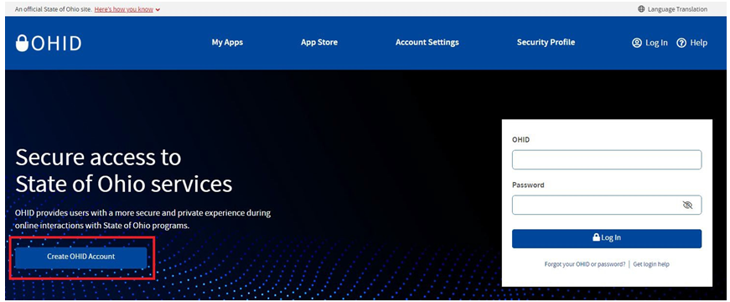

Step 2. Enter your email address. Click Send PIN to have a one-time only PIN sent to the email you provided for verification.

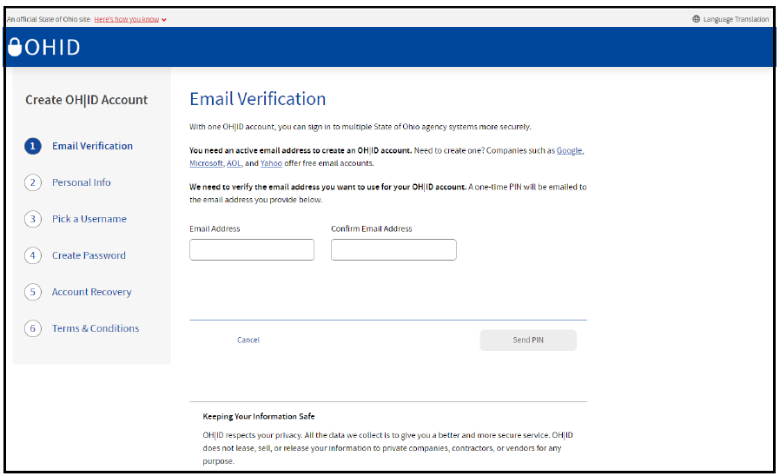

Step 3. Enter the PIN you received in the next window and click Verify. If you did not receive an email, check to make sure your email address is typed correctly and search your junk and spam folders. The system-generated email usually arrives within a few seconds but may take up to several minutes. If necessary, click Send New PIN to invalidate the previous PIN and send a new one to your email.

Once your email is verified, click Next.

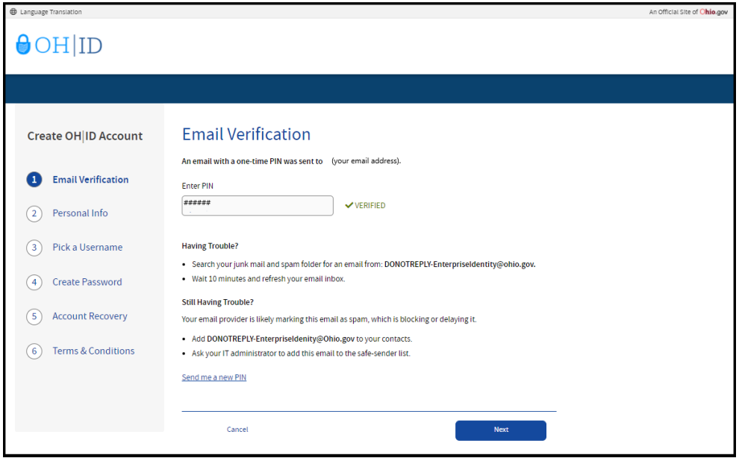

Step 4. Enter your personal information and click Next.

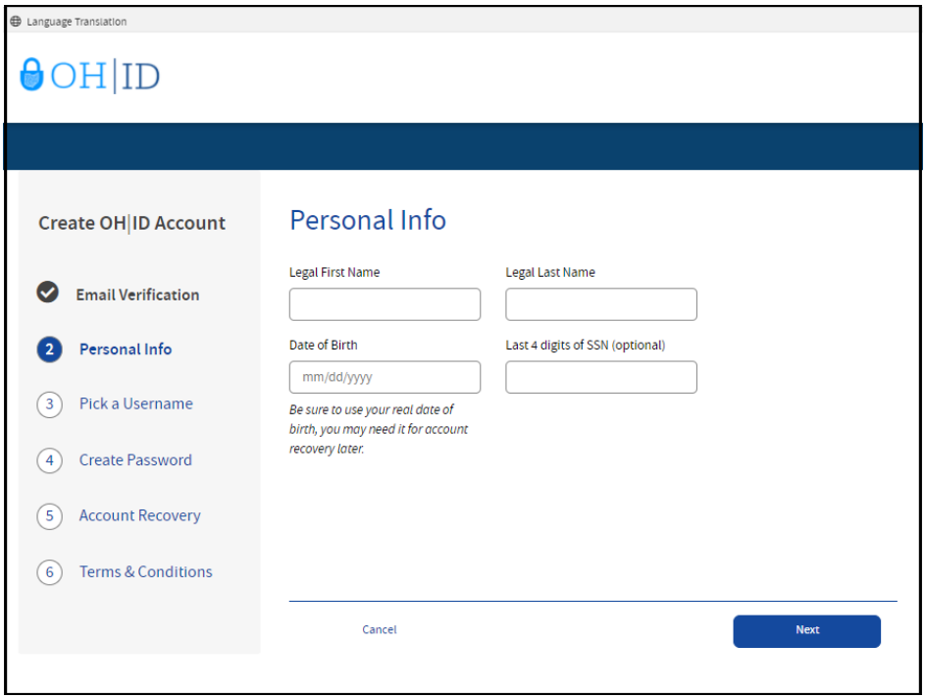

Step 5. Create a username for your OHID account and click Next.

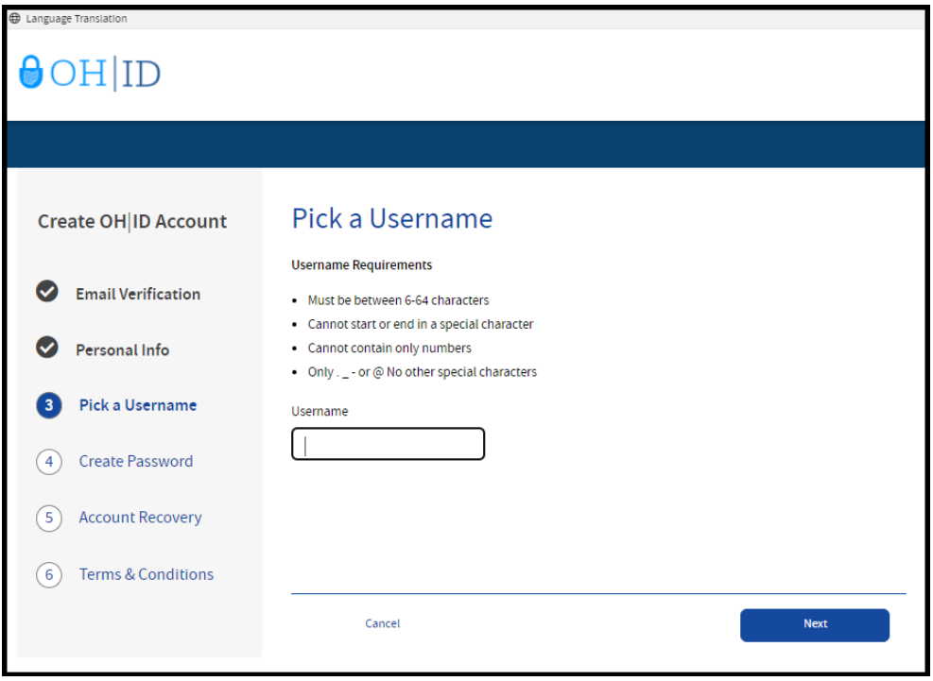

Step 6. Create a password for your OHID and click Next.

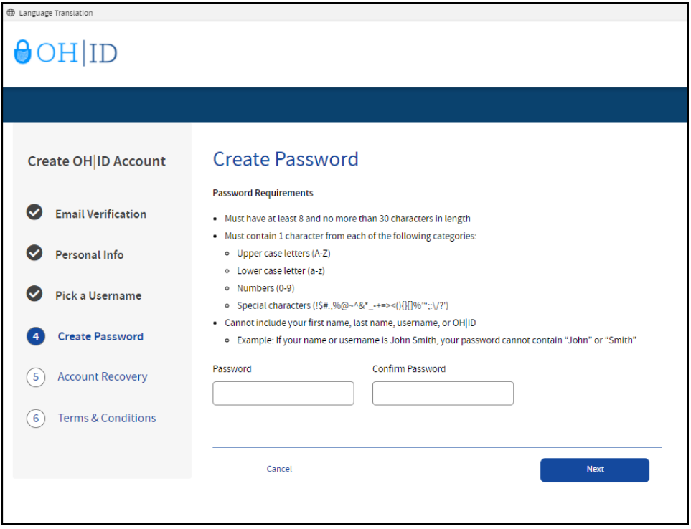

Step 7. Enter your mobile phone number to set up your mobile/text account recovery method for your OHID account and click Next.

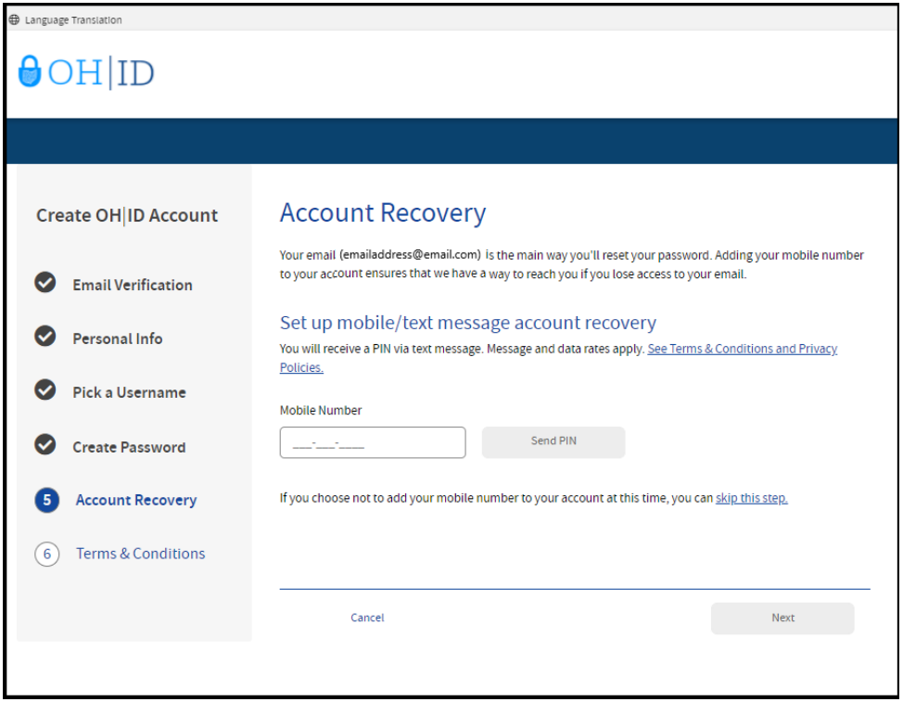

You will receive a text message with a PIN. Enter the PIN in the next OH|ID Account Recovery screen and click Verify. Once it is verified, click Next.

Step 8. Accept to the terms and conditions of your OHID account and answer the prompt to confirm you are not a robot. Click Verify. Then click Create Account.

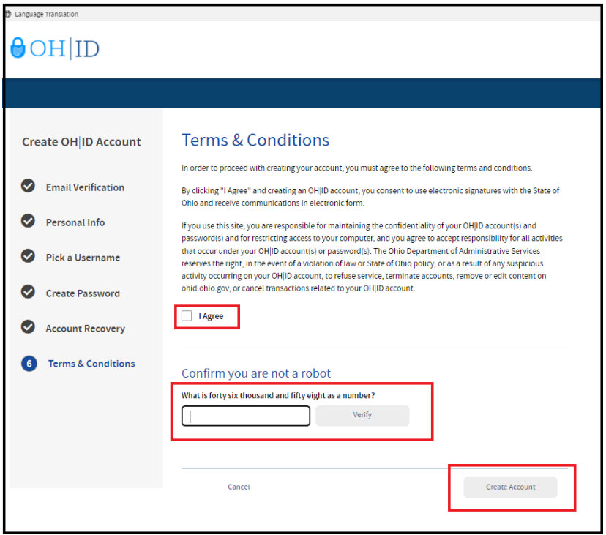

After you click Create Account, you will see a prompt to check the email address you provided when setting up your OHID account. Click log in to OHID to access your OHID account login screen. The username and password you created should already be filled in for you. If not, enter the information and click Log in.

Your next step is to create a new user profile. Please proceed to the New User Profile Setup section of this manual for instructions.

New user profile setup

You will create your user profile after setting up your OHID (or link to your existing Department of Education profile) after setting up your OHID account. Go to https://OHID.ohio.gov to log in to your OHID. Then follow the directions below.

Step 1. Click Visit the App Store.

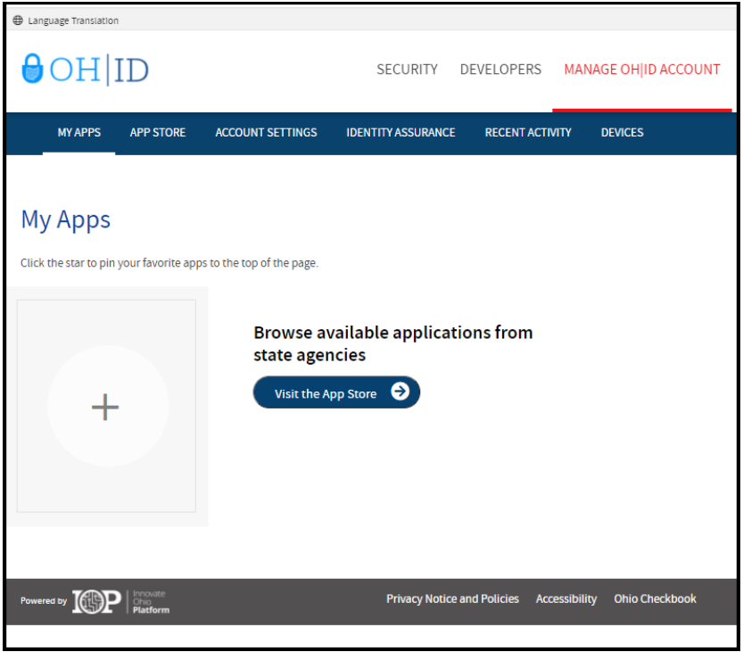

Step 2. Search for the Educator Licensure and Records (CORE) app and click the Open App button to open the User Profile screen.

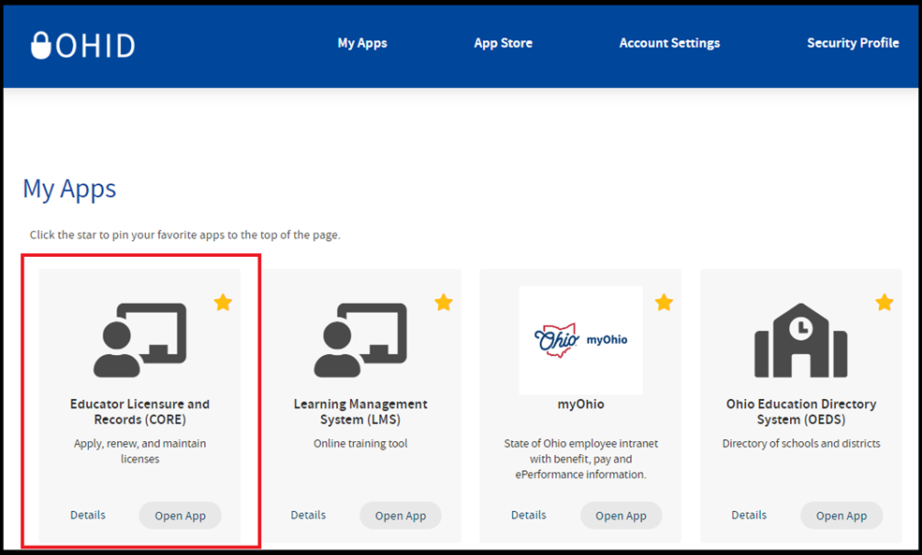

Step 3. Click the Next button.

Step 4. Enter your information on the Add Basic Information page and click Next. If you do not have a social security number (SSN) or individual taxpayer identification number (ITIN), click the box next to I do not have an SSN or ITIN.

If you indicated that you do not have an SSN or ITIN, you will be prompted to upload a document to verify your identity. Please review acceptable forms of identification on the Identity Verification webpage and upload the appropriate documentation.
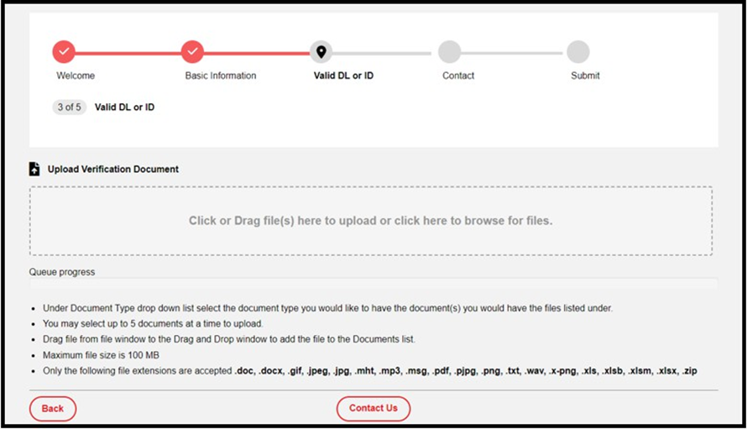

If your identity could not be verified with your SSN or ITIN, you will be prompted to provide your Ohio driver’s license information in the Identity Verification section and click Verify. If you do not have an Ohio driver's license, review other acceptable forms of identification on the Identity Verification webpage. Upload the appropriate documentation, click the I agree to the Department’s data privacy policy box, and click Next.

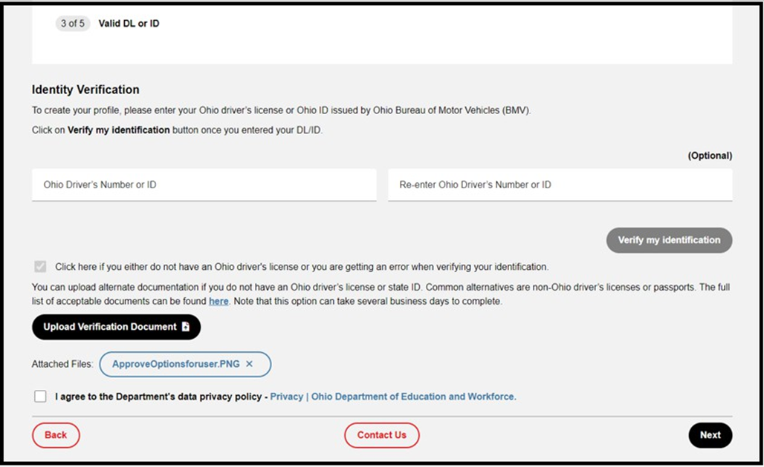

Step 5. Once your identity is verified by the system, you will be prompted to agree to the Department’s data policy. Click the I agree to the Department’s data privacy policy box. Then click Next.
Step 6. Provide your contact information in the next section and click Next. If a potential match is detected, you will see the Duplicate Prevention screen. Select your information (address, email, and phone number) and click Next.
Step 7. Review your information on the Review and Submit screen and click Submit.
Once your user profile is approved you may request an Educator State ID. Please proceed to the Request an Educator State ID section of this manual.

REQUEST AN EDUCATOR STATE ID

The next step is to request an Educator State ID number for use in the CORE system. The Educator State ID is necessary to complete an application for licensure. Educator State IDs also help State Board of Education staff identify and eliminate the occurrence of duplicate records in the database.

Please complete the following steps to request an Educator State ID:

Step 1. First, you must have an OHID account and create a user profile. If you have not completed these steps, please follow the instructions beginning in the Create an OHID Account section of this manual.

Step 2. After you have created an OHID account and user profile, navigate to https://OHID.ohio.gov/ and log in to your OHID account.
Step 3. Open the Educator Licensure and Records (CORE) app under My Apps.

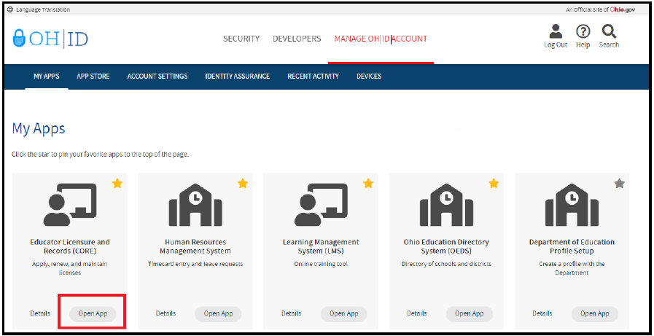

Step 4. Click My Profile in the red ribbon at the top of your CORE Dashboard.

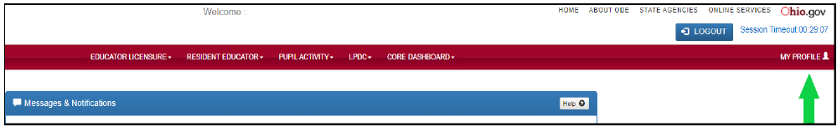

Step 5. Click Obtain Educator State ID and answer the questions in the pop-up box. If you answer Yes to any of these questions, you already have an Educator State ID. You may be prompted to select an account that matches your demographic information. Once you have answered all the questions correctly, your Educator State ID will be assigned automatically and appear on your CORE Dashboard under My Educator State ID.
Please note: If you are a credentialed educator in the State of Ohio, you already have an Educator State ID. You will see it on your CORE Dashboard under My Educator State ID and in My Profile under Educator State ID.

IF you are a credentialed educator in the State of Ohio and the Obtain Educator State ID button appears, you may have a duplicate record. This requires maintenance in the data system. DO NOT click Obtain Educator State ID if you are a credentialed educator. Please contact Educator Licensure Customer Support at Educator.Licensure@sboe.ohio.gov to correct the duplicate records.

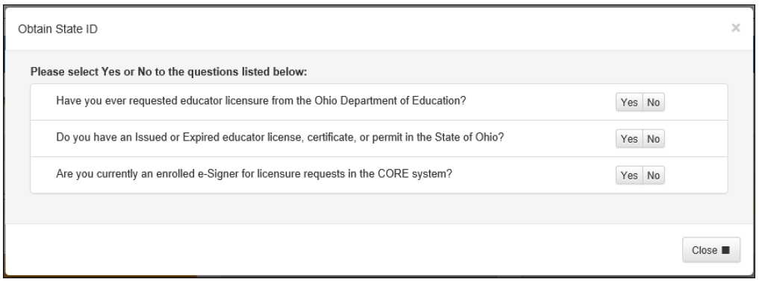

You are now ready to access the CORE system. Please proceed to the Access the CORE System section of this manual.

ACCESS THE CORE SYSTEM

Once you have set up your OHID account and created your user profile, you may log in and access the CORE system.

Navigate to https://OHID.ohio.gov/ and log in to your OHID account. Then click Open App in the Educator Licensure and Records (CORE) app to access your CORE Dashboard where you will complete your application requests.

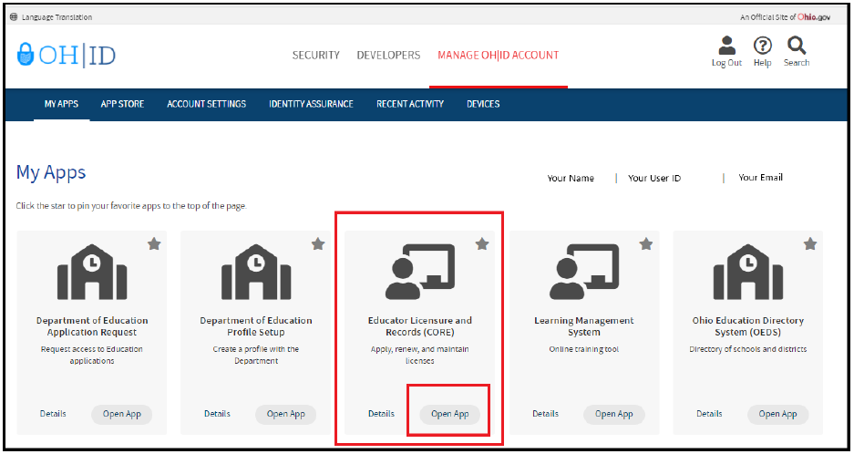

Please note that if you have never been issued an Educator State ID number before, you must complete the process and obtain one before you can submit an online licensure application. See the Request an Educator
State ID section of this manual before continuing.

CORE Dashboard

Your CORE Dashboard allows you to access the features in CORE. The items that appear on your CORE Dashboard are customized to you. The red ribbon at the top of the page will indicate access areas based on your unique user role(s).

DASHBOARD FEATURES
- The Messages & Notifications box at the top of the page displays the most recent notifications that may affect you.

- The HELP icon in the blue ribbon at the top of the Messages & Notifications box links to a list of helpful resources including contact information for the Office of Educator Licensure.
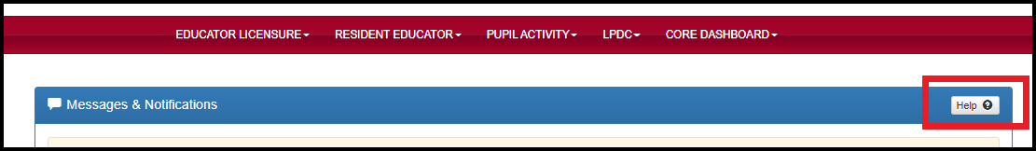

- My Credentials displays your active and historical credential information. From this section, you may begin an application for a new license or renew, advance, align or transition currently held licenses. You also may download and print a copy of your active credential. NOTE: You must click View History to see a full list of your credential history.

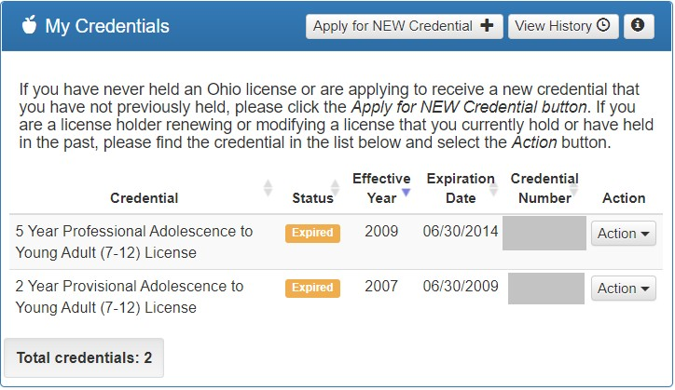

- My Account displays your payment history and current account balance. You may make a payment from this section. Submitting a payment is easy with the secure, online system that accepts credit cards and electronic checks (e-checks) for licensure applications. You may also request a refund if you have a positive balance available that you will not be applying toward a future application.

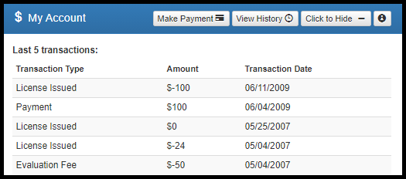

- My Documents displays documents you have uploaded to your account. You may upload required transcripts and other documents by clicking Upload Documents and following the prompts.

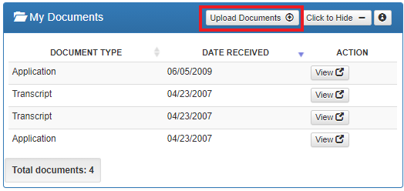

- High Performing Educator Summary displays your eligibility criteria information for the consistently high- performing teacher designation.

- My Application Status displays the status of your application(s). You may check the status of an application you submitted or edit, delete or submit an application you began previously. You may only edit or delete an application you have not yet submitted. Click Action next to the credential application you need to edit. You may change any information except the type of credential you requested. You may also and pay and submit an application you previously started. If you requested the wrong credential, you must delete the application request and start a new one. Note that submitted applications cannot be deleted. If you submit an application in error, please contact the Office of Educator Licensure to have it declined.
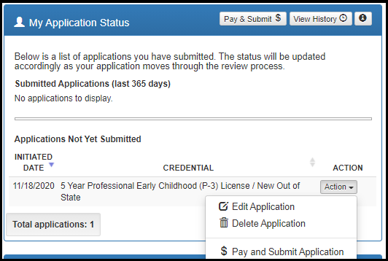

- My Background Checks displays the history of BCI and FBI background checks that have been reported to the Department of Education.

- My Resident Educator Summary allows Resident Educator and Alternative Resident Educator license holders to view their progress in the Resident Educator program and the results of any Resident Educator Summative Assessment scores.

- Assessment Data displays your licensure exams that have been reported to the Ohio Department of Education.

submit an application for licensure

APPLICATION INFORMATION
During the application process you will be prompted to provide information related to your licensure request. All applications will include some basic questions regarding your Ohio residency, eligibility for the military fee waiver and criminal history. Additionally, you must electronically sign your application by selecting Yes in the Applicant Signature section. Please see below for information regarding some prompts you may see in your application.

- Effective Date. You will need to select an effective year for your license or permit during the application process. Note that all credentials will be “effective” on July 1 of the chosen effective year.
- Required Signatures. If your application requires approval from an employing school, district, educational service center or from an Ohio college or university, you must enter the Information Retrieval Number (IRN) provided by the organization or the name of the organization. Select the correct organization by clicking the name or IRN in the list that populates after you type it. You also may click Find and type the IRN or organization name in the pop-up box provided and click Find Organization. If you accidentally select the wrong organization, simply click Reset to clear the selection.
- Documents. Your application may require the submission of documents, which you may upload in your application. Please note that you may also open and view your previously uploaded documents while you are still completing your application.
- Transcripts. If a university transcript is required to process your application, please scan and upload your original, official university transcript in PDF format. Do not submit grade reports, photos of transcripts or unofficial transcripts. It is not necessary to resubmit transcripts already in your file. Please see the following instructions before uploading your transcripts.
  - The date your degree was awarded must be visible.
  - Include all pages of your transcript (front and back).
  - The registrar’s signature must be visible.
  - The transcript key or guide must be included.
  - Create one PDF file per university transcript (do not upload pages separately).
  - Upload transcripts from multiple universities separately (each transcript must be one PDF file).
  - Electronic transcripts may only be sent directly from the issuing college or university to Educator.Licensure@sboe.ohio.gov.
  - Do not submit transcripts that will expire or are password protected or locked.
  - International Credentials: You must provide a course-by-course analysis from a Department approved international credential evaluation service for college coursework completed outside the United States. Please see the Department’s list of approved organizations.
  - If you would prefer to mail your original, official transcripts, please use the following address:
Office of Educator Licensure and Effectiveness
William Green Building
30 W. Spring Street, 12th Floor
Columbus, OH 43215
- Criminal History and Prior Licensure Discipline Questions. Please refer to Appendix A of this manual for assistance with answering questions about criminal history or prior licensure disciplinary actions.
- A Note About Bundling Applications. You may bundle multiple applications of the same license type and action and pay for all of them at once. For example, if you have multiple five-year professional licenses to renew, you may bundle them and submit one application and payment. Click Request Additional Credential at the bottom of the application.

APPLY FOR NEW LICENSE

You must have an OHID account, a Department of Education Profile and an Educator State ID to access a licensure application. If you have not completed these steps, please follow the instructions beginning in the Create an OHID Account section of this manual. Then complete the steps below to apply for a NEW license or permit.

Step 1. Navigate to https://OHID.ohio.gov and log in to your OHID account.
Step 2. Click the Educator Licensure and Records (CORE) app.

Step 3. Verify your information under My Profile before starting or submitting an application. Click My Profile in the red ribbon at the top right of the screen on your CORE Dashboard and update your information by clicking the edit icon.
- Click Edit in the section that needs updated and make the necessary changes in the pop-up box.
- Click Save.
- Click Return to Page when you are finished updating your information.
- Click Go back to Dashboard to return to your CORE Dashboard.
PLEASE NOTE: It is important to keep your information current. The Office of Educator Licensure and Effectiveness uses the information in My Profile to contact applicants regarding their applications.
Step 4. Click Apply for a NEW Credential in the My Credentials section on your CORE Dashboard.

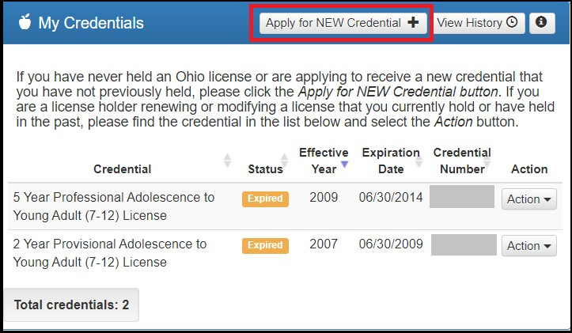

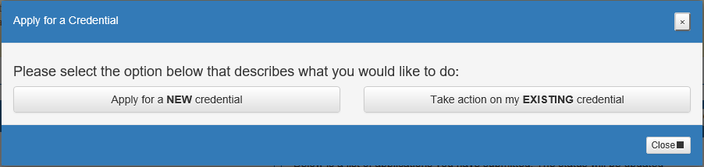
Step 5. In the pop-up box, click Apply for a NEW credential to begin the application for a new license or permit. NOTE: Do not click Apply for a NEW credential if you are renewing a license or permit or adding an endorsement to your existing license.

The next screen is organized by categories of licenses. Click the category to view a list of available licenses. Example: Click Substitutes to view a list of all licenses for which a substitute teacher may apply. Select a license type to get a full description of that credential and helpful links to more information for out-of-state applicants, background checks and other requirements.

Step 6. The next screen is organized by categories of licenses. Click the category to view a list of available licenses. Click Substitutes to view a list of all licenses for which a substitute teacher may apply.

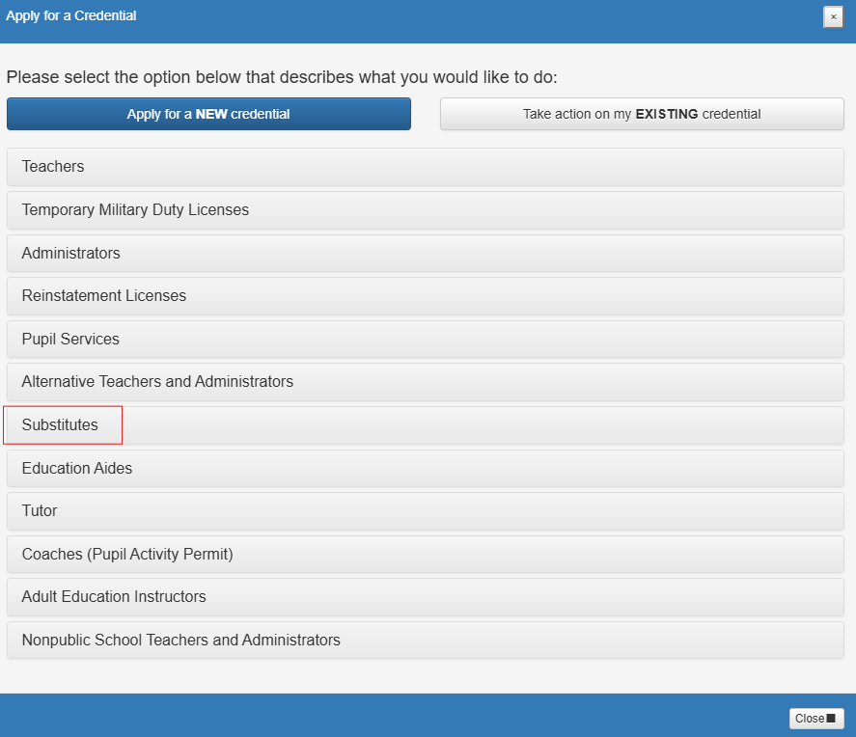

Select type of license and click Apply.

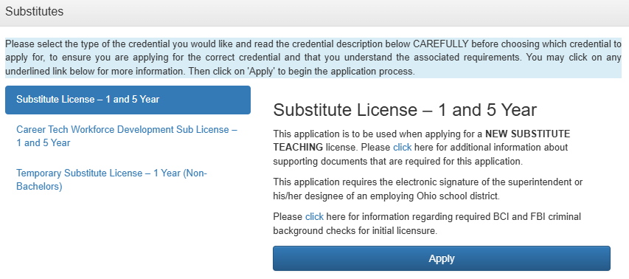

Please note: If applying for a Temporary Substitute License, please refer to those instructions.

Step 7a. A pop-up screen will prompt you to select the credential type and effective year of your new license or permit.

Step 7b. Once you have supplied the requested information, click Start Application Process to begin the application.
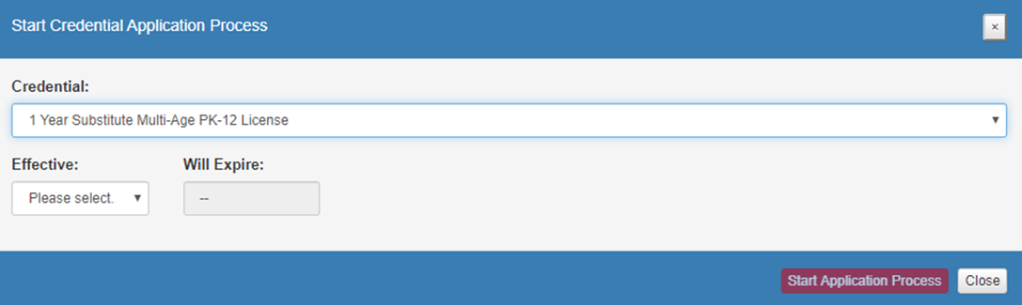

Step 8. The next screen will be the Requested Credentials screen, where you will submit the information required for the licensure application. Endorsements are issued based on degree earned. Select the endorsement that matches your degree earned. If your degree is in education, select Education Degree-Unlimited. If your degree earned does not match any of the endorsements, please select General Substitute. If you choose an area outside of your degree earned, ODE will reject your application. Please call the OSTS Service Center at 216.446.6787 if you have questions.

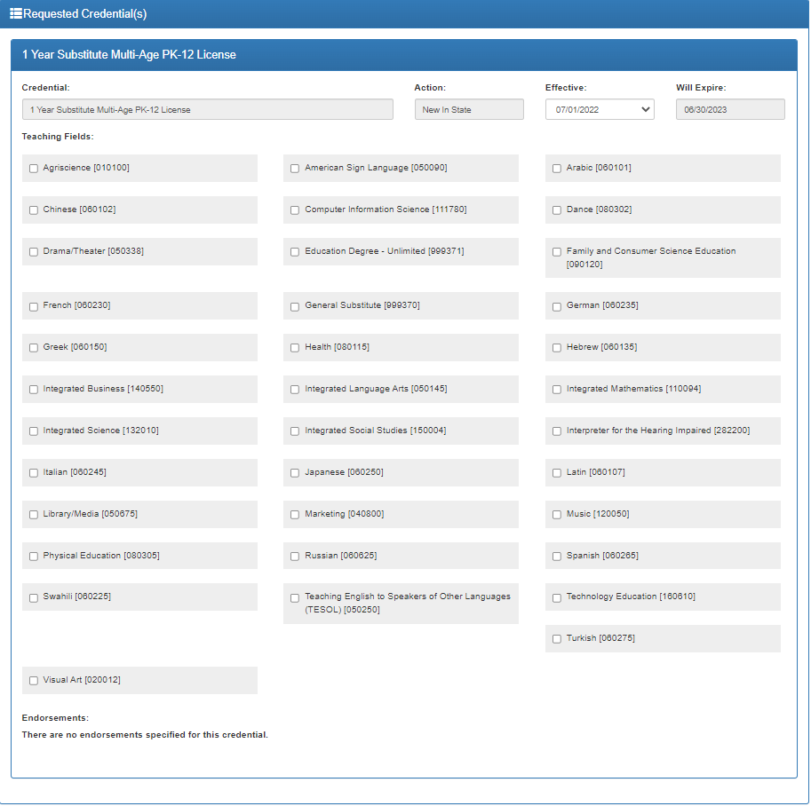

Step 9. All applications will include some basic questions regarding your Ohio residency, eligibility for the military fee waiver and criminal history.

Step 10a. Upload any documents required for the licensure application, such as official university transcripts, military ID and so on, under the Documents section of the application. You may also view previously submitted documents in your account by clicking View next to the document. Click Upload Documents to begin the process of uploading your documents.

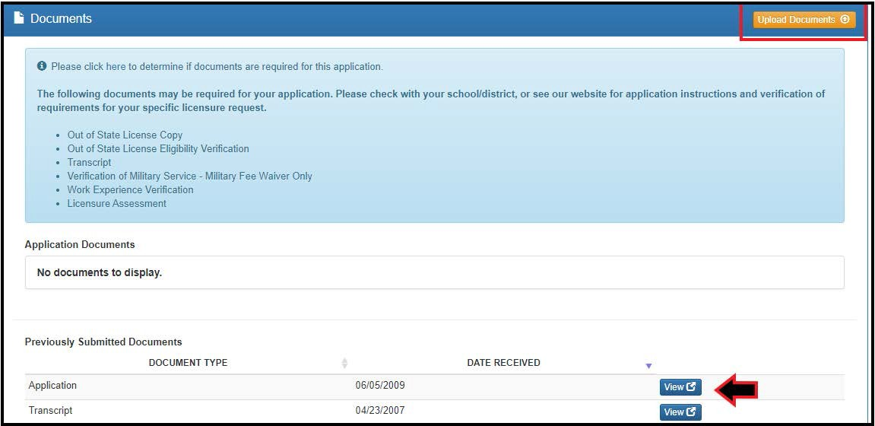

Step 10b. Select the type of document you are uploading from the drop-down menu under Document Type
(Transcript, for example). Then click Browse to locate the document on your computer.
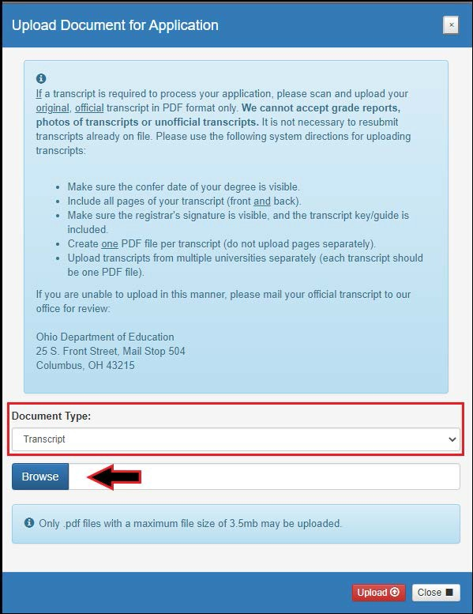

Step 10c. Select your document and click Upload. You will then see your uploaded document under Application Documents. You may view or delete the document before proceeding with the rest of the application.

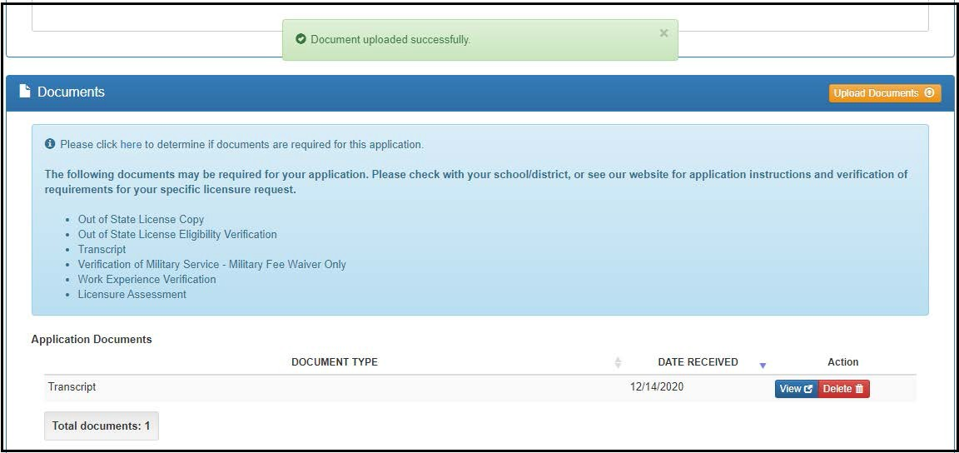

Step 11a. Your application requires approval from your employer. Click Find.

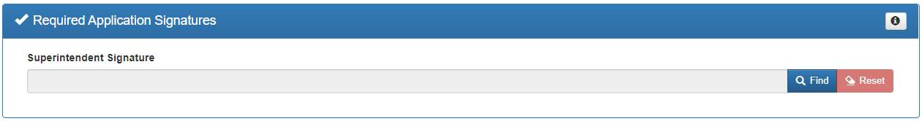

Step 11b. Type our IRN # 046532 in the IRN box. Click Find Organization.

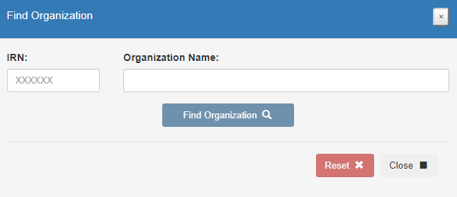

Step 11c. A pop-up window will appear. Click on the Select button.

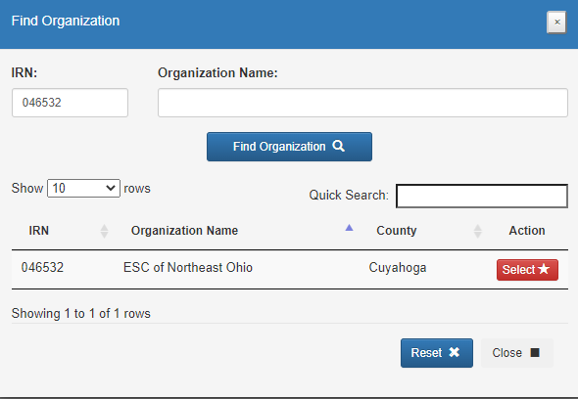

Step 12a. After you have answered all the questions and uploaded your documents (if required), click Yes in the Applicant Signature section to electronically sign your application.

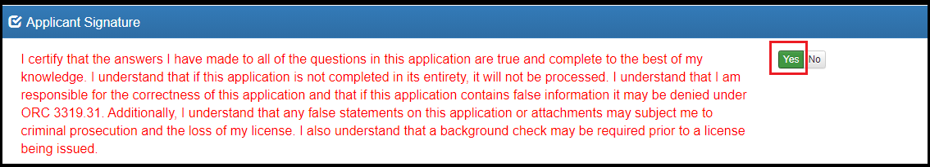

Step 12b. If you are ready to submit your application, click Pay and Submit Application. If you are not ready to submit your application, you may click Return to Dashboard or Save and Exit (Without Submitting).

You may reopen your application later to finish and submit by clicking the Action drop down next to the application you initiated under My Application Status on your CORE Dashboard. See the Dashboard Features section of this manual for information on editing an application.

If you clicked Pay and Submit Application, you will proceed to the payment section of your application. Please go to the Application Payment section of this manual for instructions.

APPLICATIONS FOR RENEWALS

You must have an OHID account, a Department of Education Profile and an Educator State ID to access a
licensure application. If you have not completed these steps, please follow the instructions beginning in the Create an OHID Account section of this manual. Then complete the steps below to take action on an existing license, such as to renew or add an endorsement.
Returning and renewal applicants who have previously held licenses or permits are required to disclose any new criminal offenses or professional license discipline that have occurred since the time you last applied. See Appendix A for more information.

Step 1. Navigate to https://OHID.ohio.gov and log in to your OHID account.

Step 2. Click the Educator Licensure and Records (CORE) app and launch it.

Step 3. Verify your information under My Profile before starting or submitting an application. Click My Profile in the red ribbon at the top right of the screen on your CORE Dashboard and update your information by clicking the edit icon.
- Click Edit in the section that needs updated and make the necessary changes in the pop-up box.
- Click Save.
- Click Return to Page when you are finished updating your information.
- Click Go back to Dashboard to return to your CORE Dashboard.

PLEASE NOTE: It is important to keep your information current. The Department uses the information in My Profile to contact applicants regarding their applications.

If you are renewing a Substitute Teaching License, continue below. If you are renewing a Professional License, skip to Renewing a Professional License section.

RENEWING SUBSTITUTE TEACHING LICENSE

Step 1. From your CORE Dashboard under My Credentials, select the Action button next to your previously issued credential and select the Renew from the dropdown menu.

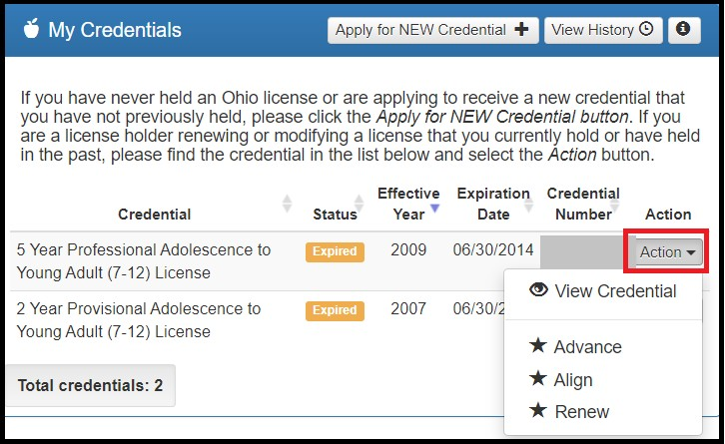

Step 2. Complete all Steps outlined beginning at Step 5 on page 16 under Substitute License.

RENEWING PROFESSIONAL LICENSE
Please note: The information provided is intended for substitute teachers with a Professional License. If you are employed by a district or the ESC, please consult your LPDC before beginning the renewal process.

Step 1. To begin, complete above Steps 1-3 under Applications for Renewal.

Step 2. From your CORE Dashboard under My Credentials, select the Action button next to your previously issued credential and select the appropriate action from the dropdown menu, such as Advance, Align, Renew, or Transition.

Step 3. For those renewing a teaching license, you will need to indicate how you met renewal eligibility requirements if you are renewing a professional administrator, educator or pupil services license. If you are employed in an Ohio school or district and renewing through your Local Professional Development Committee (LPDC), for example, you will indicate that in the application under the Renewal Eligibility section of the application.

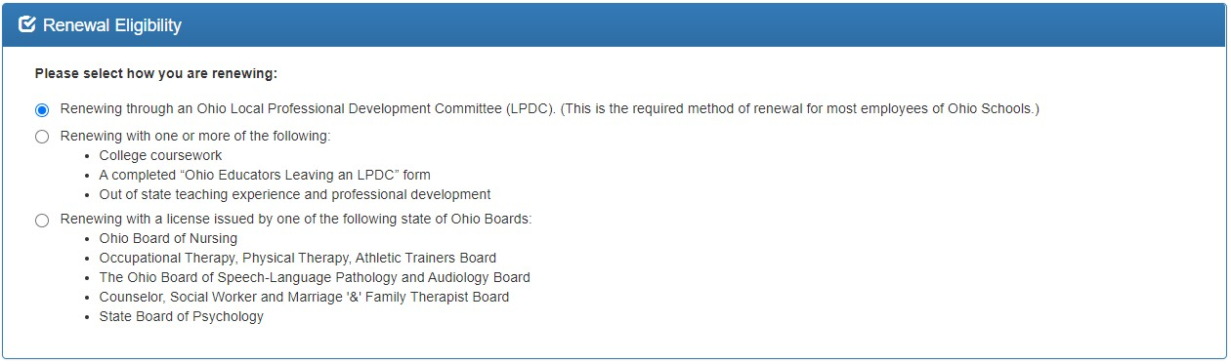

Substitute Teachers renewing a Professional License need six semester hours of coursework related to classroom teaching or area of licensure from an accredited two-year or four-year institution of higher education completed after the last issue date of the expiring license. Educators must complete all renewal coursework and submit their renewal application prior to October 1 of the expiration year of the license to be renewed, or the renewal requirement increases to nine semester hours.

Please note that the Department DOES NOT pre-approve coursework. Renewal requirements are in place to keep educators abreast of best practices in the field and the latest research findings. Classroom dynamics change constantly, and continuing education helps teachers find new ways to reach students and help them succeed. All coursework must lead to new knowledge in the P-12 classroom and be related to student success, wellness or achievement. Renewal coursework must be relevant to classroom teaching or area of licensure. The Department will also consider coursework completed for an additional P-12 licensure area for renewal of an expiring license. Courses which provide credit for completing routine teaching duties and responsibilities and courses in which the curriculum is selected by the educator rather than the university will not be accepted, even if reflected on an official transcript from an accredited.

For more information, visit ODE’s website at https://sboe.ohio.gov/educator-licensure/renew-a-license/renew-an-advanced-associate-or-professional-license.

Step 4a. Upload any documents required for the licensure application, such as official university transcripts, military ID and so on, under the Documents section of the application. You may also view previously submitted documents in your account by clicking View next to the document. Click Upload Documents to begin the process of uploading your documents.

Step 4b. Select the type of document you are uploading from the drop-down menu under Document Type
(Transcript, for example). Then click Browse to locate the document on your computer.

Step 4c. Select your document and click Upload. You will then see your uploaded document under Application
Documents. You may view or delete the document before proceeding with the rest of the application.

Step 5a. After you have answered all the questions and uploaded your documents (if required), click Yes in the Applicant Signature section to electronically sign your application.

Step 5b. If you are ready to submit your application, click Pay and Submit Application. If you are not ready to submit your application, you may click Return to Dashboard or Save and Exit (Without Submitting).

You may reopen your application later to finish and submit by clicking the Action drop down next to the application you initiated under My Application Status on your CORE Dashboard. See the Dashboard Features section of this manual for information on editing an application.

If you clicked Pay and Submit Application, you will proceed to the payment section of your application. Please go to the Application Payment section of this manual for instructions.

APPLICATION PAYMENT

If you have completed your application and you are ready to pay and submit it, please see the directions below.

Step 1. If you saved your application to submit later, begin by navigating to https://OHID.ohio.gov and log in to your OHID account.

Step 2. Click the Educator Licensure and Records (CORE) app.

Step 3. You will see My Application Status on your CORE Dashboard. Click the Action button next to the application you started. If you did not yet complete your application questions, click Edit Application to open it and answer any remaining questions. If you completed the application but still need to submit your payment, click Pay and Submit Application.

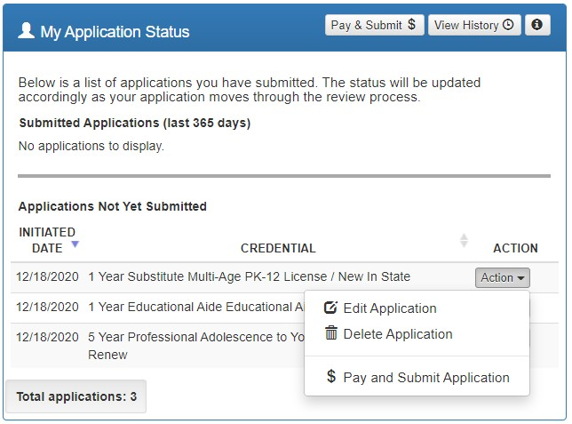

Step 4. Click Include for the application(s) you wish to submit in the Pay and Submit Applications pop up box. You will see the total amount due for the applications you selected.
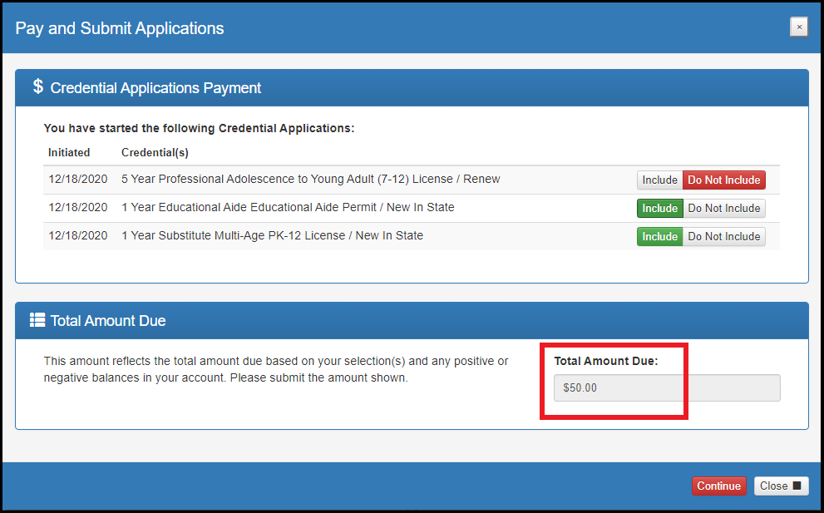

Step 5. After you click Continue, you will see a pop-up box verifying you are navigating to the external payment site to process your secure, online payment. Click Continue to navigate to the payment site, or click Cancel if you do not wish to proceed. Do not click your browser’s “back” button from this screen.
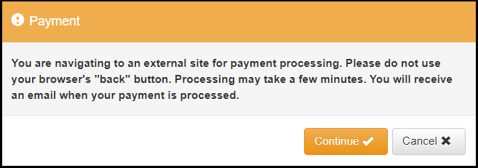

Step 6. You may pay for your application with a credit card or electronic check (E-check). Select one of these choices in the Payment Method drop-down menu. Then click Next.
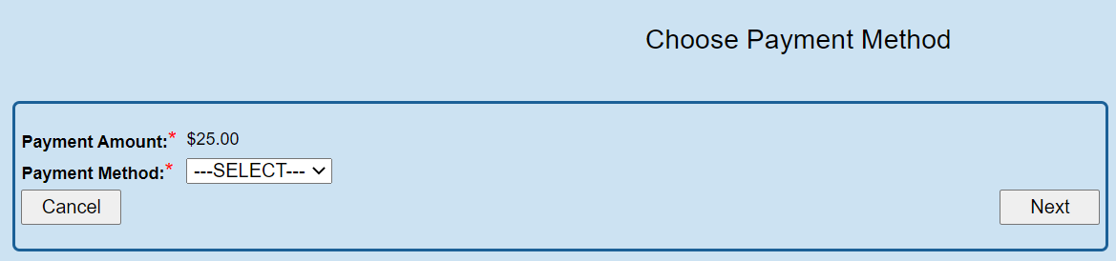

E-CHECK PAYMENT

Step 1. Select E-Check and click Next from the Choose Payment Method screen to process a payment from your bank account. Then enter the bank routing number, your bank account number and your email address. Be sure to click the Email Receipt box to have your receipt sent to you and click Review to proceed.
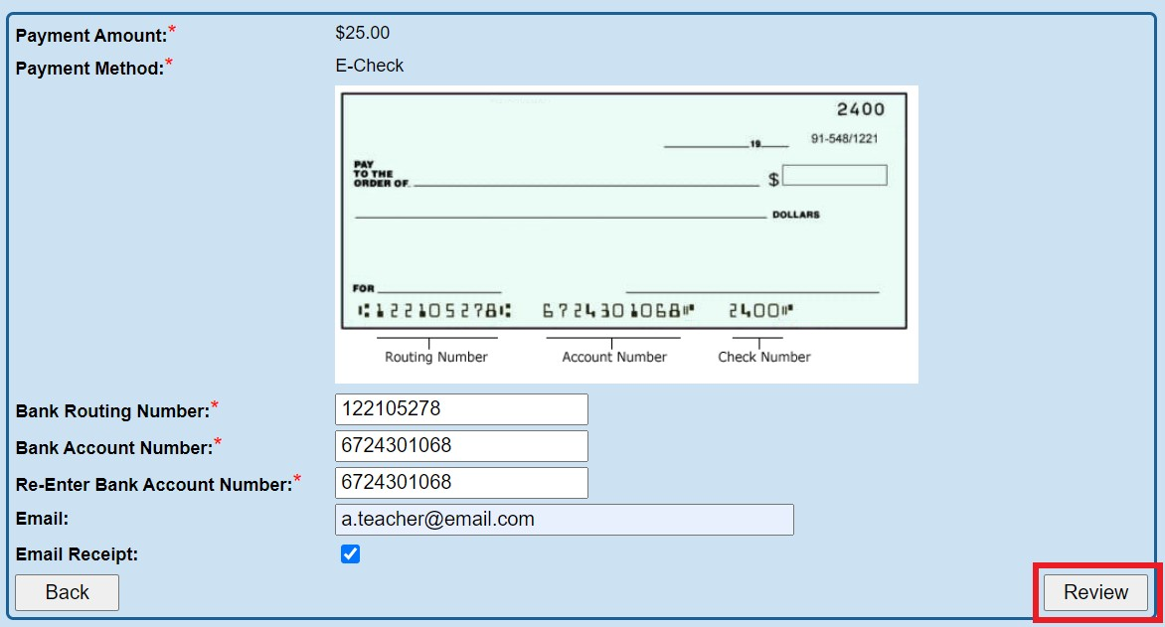

Step 2. Review the details on the Review Payment Details screen and click Make Payment if the information displayed is correct. If you need to make changes, click Back to return to the previous screen.

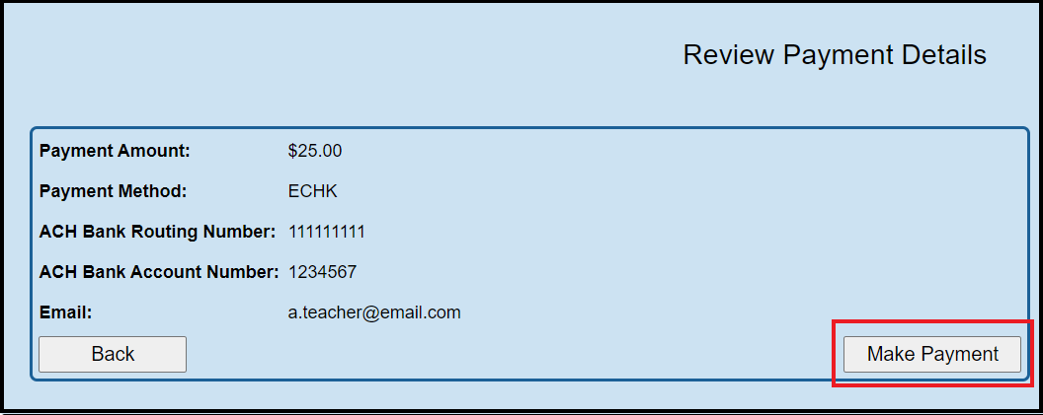

While your payment is processing, a spinning circle will appear. DO NOT press any keys on your keyboard or use your mouse during this time to ensure proper payment processing.

After your payment is processed, you will return to your CORE Dashboard where you may view the status of your application. In the My Account section of your CORE Dashboard, you will see your payment posted to your account. You will receive an email confirmation once you have submitted your application.

CREDIT CARD PAYMENT

Step 1. Select Credit Card from the Choose Payment Method screen to process a credit card payment. The following credit cards may be used: American Express, Discover, Master Card or Visa. Please note: You must use a credit card or a debit card that does NOT require a PIN. Cards that require a PIN are not accepted. Prepaid cards are only acceptable if they do not require a PIN.

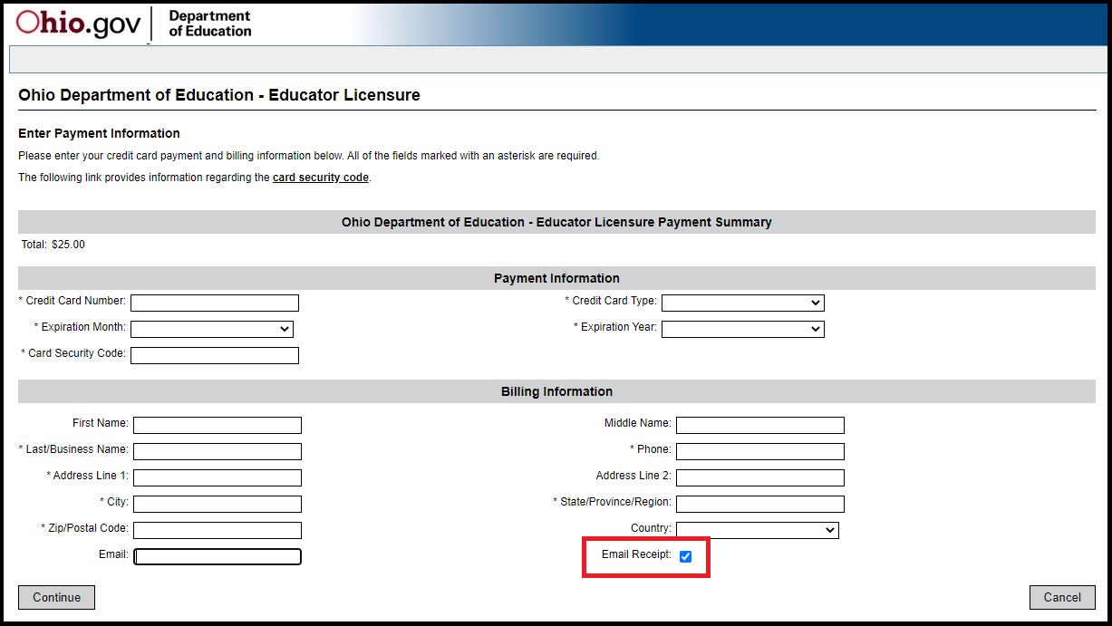

Step 2. Enter your information on the credit card payment screen. The fields indicated with an asterisk are required. You must provide an email address and make sure the Email Receipt box is checked to receive an email confirmation of your payment. Click Continue when you are finished.

Step 3. Review the details on the following screen and click Confirm if the information displayed is correct. If you need to change any information, click Back to return to the previous screen.

While your payment is processing, a spinning circle will appear. DO NOT press any keys on your or use your mouse during this time to ensure proper payment processing.

Step 4. Print Receipt (for credit card payments only). Your receipt will appear on the next screen. You may print this for your records. You also will receive an email receipt if you checked the Email Receipt box and provided your email during the payment process. Click Continue.
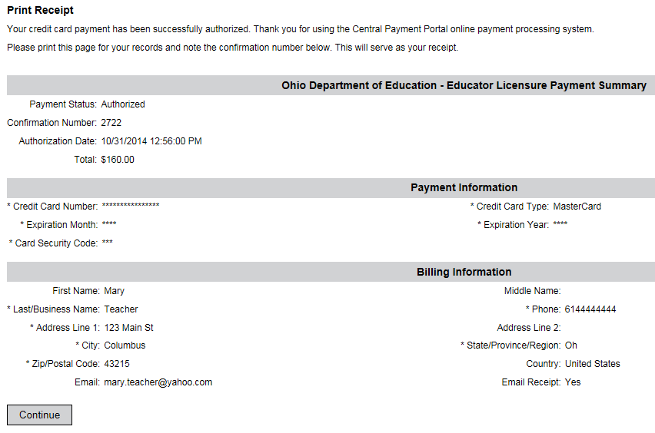

After your payment is processed, you will return to your CORE Dashboard where you may view the status of your application. In the My Account section of your CORE Dashboard, you will see your payment posted to your account. You will receive an email confirmation once you have submitted your application.

OHID ACCOUNT HELP

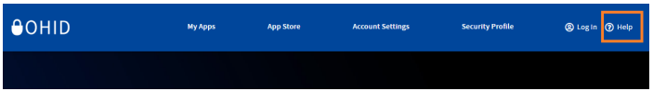
Should you need any assistance with your OHID account, including editing your profile, changing your password, or setting up your security options, simply click the Help icon at the top of your OHID account screen.

From the OHID Help page, you can look up how to edit your profile, change your password or make changes to your personal information.

EDIT PERSONAL INFORMATION

You may update your personal information (including contact information), password or password recovery options after you have set up your OHID account. Please note that updating your personal information is a two-part process. First you will update your information in your OHID account. Then you will update your information
in the CORE system.

PART 1: UPDATE OHID ACCOUNT
Begin by navigating to https://OHID.ohio.gov/ and log in to your OHID account. Then follow the steps below.

Step 1. Click the Account Settings tab in the blue ribbon at the top of the screen.

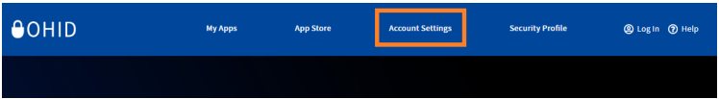

Step 2. On the Account Settings page select the area you wish to update. Edit your information and click Save Changes.
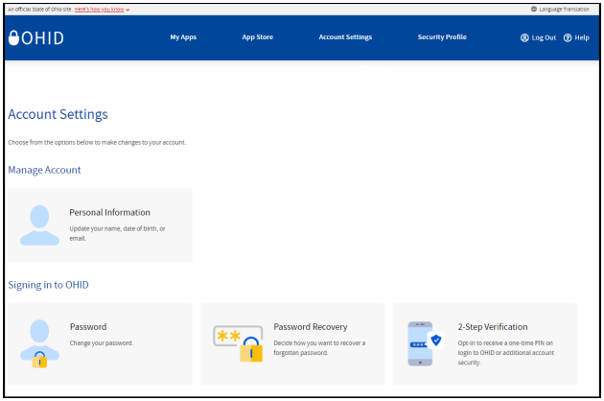

PART 2: UPDATE CORE ACCOUNT

Step 1. To update your information in your CORE account, click the My Apps tab in the blue ribbon at the top of your OHID account page and then open the Educator Licensure and Records (CORE) app. Note: You may need to click Launch to open Educator Licensure and Records (CORE).
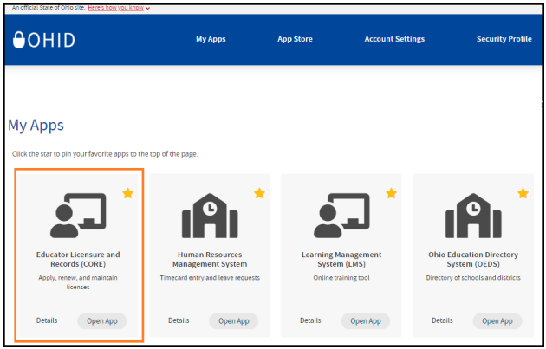

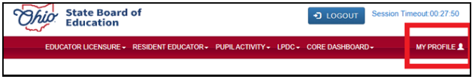
Step 2. Click My Profile in the red ribbon at the top right of the screen on your CORE Dashboard.

Step 3. Update your information (address, phone, or email) by clicking the edit icon.
- Click Edit in the section that needs updated and make the necessary changes in the pop-up box. Then click Save.
- Click Return to Page when you are finished updating your information.
- Click Go back to Dashboard to return to your CORE Dashboard.

NAME CHANGE

Please follow the directions below to change the name that appears on your educator license or permit. Please note that the name on your educator license must match the name on your current, valid Ohio driver’s license or state ID card. If your driver’s license or state ID card reflects a different name, you must first update your state ID at the Bureau of Motor Vehicles. The process to change your name in CORE and your OHID account will not work if your name does not match what appears on your driver’s license or state ID card.

Updating your name is a two-part process. First you will update your name within CORE. Then you will update your name in your OHID account.

Part 1. Update your name in CORE.

- Login to your OHID account (https://OHID.ohio.gov).
- Under My Apps, click Educator Licensure and Records (CORE).
- At the top of the screen, you will see Welcome and then your name.
- Click your name. The screen will show the contact information for your CORE account.
- Click Manage Name. A warning will display.
- Click Change Name to proceed.
- Enter your Ohio driver’s license or state ID number. If you do not have an Ohio driver’s license or state of Ohio ID card, select click here to upload a scanned copy of your identification card.
- Enter your first name, middle name, and last name. Please note, this information must match exactly as it appears on your current Ohio driver’s license or state ID card.
- Click Save. Your updated information should now be displayed.

Part 2. Update your name in your OHID account.

- After completing the directions above, click the blue LOGOUT button in the upper right of MY HOME PAGE. Your screen will update, and you will be routed to the OHID Dashboard.
- Click the small triangle to the right of the User Account Management menu. This will open a menu with an option to Update Profile. On the Update Profile screen, you can update all your information. Update your profile name to match what you entered in CORE. Your name must match exactly to link your OHID profile to your CORE profile.
- Make the necessary changes.
- Double-check the information is correct and click Update.
- Under account settings, click Manage Name to update your information.
- Log out.
- Close all browser windows.
- Log back in.

Logging out and logging back in is essential for allowing the system to update your profile. You may verify your updated information by viewing your CORE profile and your OHID profile. You may also print a revised copy of your active license or permit reflecting your name change under My Credentials from your CORE Dashboard.

If you encounter any error messages during this process, please email Contact.Center@sboe.ohio.gov with the error message and a summary of what you are trying to accomplish.

APPENDIX A

CRIMINAL HISTORY AND PRIOR LICENSURE DISCIPLINE QUESTIONS
This section of the licensure application requires you to answer five questions related to your criminal history and prior professional license discipline. There are different questions for first-time applicants and returning/renewal applicants. For additional information, please see the Criminal Records webpage.

Please see below for specific instructions on each question for first-time applicants and for returning/renewal applicants. If, after reviewing the guidance below, you still need assistance in completing your responses to these specific questions, you may contact Educator.Conduct@sboe.ohio.gov.

FIRST-TIME APPLICANTS
Keep in mind that as a first-time applicant you are required to disclose the information requested in the following questions regardless of how much time has passed since the incident occurred.

Question 1:
Have you ever been convicted of any criminal offense (except misdemeanor traffic offense)?
- Click Yes if you have any criminal convictions, misdemeanors and/or felonies, guilty pleas, convictions based on plea of no contest or a plea of nolo contendere (including an Alford plea), and felony traffic offenses.
- If you click Yes, you will be directed to provide full details of each conviction:
  - Fill out the Year of conviction.
  - Select Offense from the drop-down menu (if you are unsure of your specific offense, you may choose “Other, Unknown” and then provide a detailed Explanation describing the offense); and
  - Provide an Explanation. Note: An explanation is not required, unless “Other, Unknown” is selected as offense type.
- After you have filled in the Year, Offense, and Explanation, you must click the blue Add button to complete your reporting of that conviction.
- Repeat this process for each conviction.
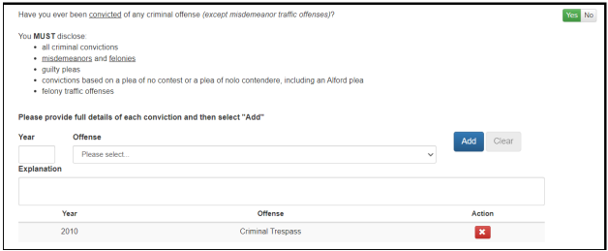

Question 2:
Are you currently a defendant in a pending criminal court case (except misdemeanor traffic offenses)?
- Click Yes if you have a pending criminal case that has not yet been resolved.
- If you click Yes, you will be directed to provide full details of your pending criminal court case:
  - Select Offense from the drop-down menu (if you are unsure of your specific offense, you may choose “Other, Unknown” and then provide a detailed Explanation describing the offense); and
  - Provide an Explanation. Note: An explanation is not required, unless “Other, Unknown” is selected as offense type.
- After you have filled in the Offense and Explanation, you must click the blue Add button to complete your reporting of that pending criminal court case.
- Repeat this process for each pending criminal court case.

Question 3:
Have you ever participated in a criminal diversion program?
- Click Yes if you have participated in a first offender’s program, a treatment in lieu of conviction program, or any other type of diversion program.
- If you click Yes, you will be directed to provide details of your criminal diversion program:
  - Fill out the Year of criminal diversion program;
  - Select Offense from the drop-down menu (if you are unsure of your specific offense, you may choose “Other, Unknown” and then provide a detailed Explanation describing the offense); and
  - Provide an Explanation. Note: An explanation is not required, unless “Other, Unknown” is selected as offense type.
- After you have filled in the Year, Offense, and Explanation, you must click the blue Add button to complete your reporting of that criminal diversion program.
- Repeat this process for each criminal diversion program.

Question 4:
Have you ever had a criminal conviction or guilty plea sealed or expunged (except misdemeanor traffic offenses)?
- Click Yes if you have ever had any criminal conviction or guilty plea sealed or expunged by a court. Ohio Revised Code Section 3319.292 grants the State Board of Education the authority to ask questions about an applicant’s sealed or expunged convictions.
- If you click Yes, you will be directed to provide details of your sealed or expunged case.
  - Fill out the Year your case was sealed or expunged. Please make sure to also fill out the Conviction Question above for this case with its appropriate year of conviction;
  - Select Offense from the drop-down menu (if you are unsure of your specific offense, you may choose “Other, Unknown” and then provide a detailed Explanation describing the offense); and
  - Provide an Explanation. Note: An explanation is not required, unless “Other, Unknown” is selected as offense type.
- After you have filled in the Year, Offense, and Explanation, you must click the blue Add button to complete your reporting of that sealed or expunged case.
- Repeat this process for each sealed or expunged case.

Question 5:
Has disciplinary action ever been taken regarding any professional certificate, license, registration, or permit that you hold or have held in Ohio or any other state or place?
- Click Yes if you have ever had any professional license, certificate, registration, or permit discipline, including letters of admonishment, reprimands, voluntary surrenders, suspensions, limitations, revocations, denials, disciplinary settlement agreements (consent agreements), or any other disciplinary actions.
- If you click Yes, you will be directed to provide full details of your professional license discipline:
  - Fill out the Year of your discipline.
  - Fill out the State and Agency where the discipline was from (example: State Board of Education of Ohio or Kentucky Board of Nursing);
  - Select the Discipline Type from the drop-down menu (if you are unsure of your specific Discipline Type, you may choose “Any Other Disciplinary Actions” and then provide a detailed Explanation describing the disciplinary action); and
  - Provide an Explanation of the disciplinary action. Note: An explanation is not required, unless “Any Other Disciplinary Actions” is selected as Discipline Type.
- After you have filled in the Year, State/Agency, Discipline Type, and Explanation, you must click the blue Add button to complete your reporting of that professional license discipline.
- Repeat this process for each professional license discipline.

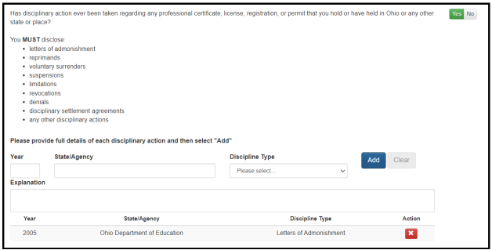

RETURNING/RENEWAL APPLICANTS
Returning and renewal applicants who have previously held licenses or permits are required to disclose any new criminal offenses or professional license discipline that have occurred since the time you last applied.

Question 1:
Since you last applied, have you been convicted of any criminal offense (except misdemeanor traffic offenses)?
- Click Yes if you have any criminal convictions for minor misdemeanors, misdemeanors, and/or felonies, including any guilty pleas, convictions based on plea of no contest or a plea of nolo contendere (including an Alford plea), and felony traffic offenses that are new since you last applied.
- If you click Yes, you will be directed to provide full details of each conviction:
  - Fill out the Year of conviction.
  - Select Offense from the drop-down menu (if you are unsure of your specific offense, you may choose “Other, Unknown” and then provide a detailed Explanation describing the offense); and
  - Provide an Explanation. Note: An explanation is not required, unless “Other, Unknown” is selected as offense type.
- After you have filled in the Year, Offense, and Explanation, you must click the blue Add button to complete your reporting of that conviction.
- Repeat this process for each new conviction.

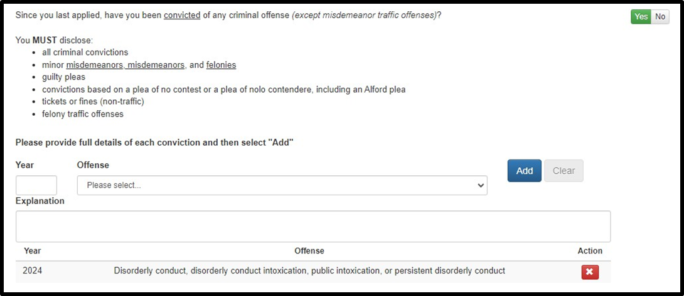

Question 2:
Are you currently a defendant in a pending criminal court case (except misdemeanor traffic offenses)?
- Click Yes if you have a pending criminal case that has not yet been resolved.
- If you click Yes, you will be directed to provide full details of your pending criminal court case:
  - Select Offense from the drop-down menu (if you are unsure of your specific offense, you may choose “Other, Unknown” and then provide a detailed Explanation describing the offense); and
  - Provide an Explanation. Note: An explanation is not required, unless “Other, Unknown” is selected as offense type.
- After you have filled in the Offense and Explanation, you must click the blue Add button to complete your reporting of that pending criminal court case.
- Repeat this process for each pending criminal court case.

Question 3:
Since you last applied, have you participated in a criminal diversion program (except misdemeanor traffic offenses)?
- Click Yes if you have participated in a first offender’s program, a treatment in lieu of conviction program, or any other type of diversion program since you last applied.
- If you click Yes, you will be directed to provide details of your criminal diversion program:
  - Fill out the Year of criminal diversion program;
  - Select Offense from the drop-down menu (if you are unsure of your specific offense, you may choose “Other, Unknown” and then provide a detailed Explanation describing the offense); and
  - Provide an Explanation. Note: An explanation is not required, unless “Other, Unknown” is selected as offense type.
- After you have filled in the Year, Offense, and Explanation, you must click the blue Add button to complete your reporting of that criminal diversion program.
- Repeat this process for each new criminal diversion program.

Question 4:
Since you last applied, have you had a criminal conviction or guilty plea sealed or expunged (except misdemeanor traffic offenses)?
- Click Yes if you have had any criminal conviction or guilty plea sealed or expunged by a court since you last applied. Ohio Revised Code Section 3319.292 grants the State Board of Education the authority to ask questions about an applicant’s sealed or expunged convictions.
- If you click Yes, you will be directed to provide details of your sealed or expunged case.
  - Fill out the Year your case was sealed or expunged;
  - Select Offense from the drop-down menu (if you are unsure of your specific offense, you may choose “Other, Unknown” and then provide a detailed Explanation describing the offense); and
  - Provide an Explanation. Note: An explanation is not required, unless “Other, Unknown” is selected as offense type.
- After you have filled in the Year, Offense, and Explanation, you must click the blue Add button to complete your reporting of that sealed or expunged case.
- Repeat this process for each new sealed or expunged case.

Question 5:
Since you last applied, have you received discipline against any professional certificate, license, registration, or permit that you hold or have held in Ohio or any other state or place?
- Click Yes if you have had any professional license, certificate, registration, or permit discipline, including letters of admonishment, reprimands, voluntary surrenders, suspensions, limitations, revocations, denials, disciplinary settlement agreements (consent agreements), or any other disciplinary actions that are new since you last applied.

- If you click Yes, you will be directed to provide full details of your professional license discipline:
  - Fill out the Year of your discipline.
  - Fill out the State and Agency where the discipline was from (example: State Board of Education of Ohio or Kentucky Board of Nursing);
  - Select the Discipline Type from the drop-down menu (if you are unsure of your specific Discipline Type, you may choose “Any Other Disciplinary Actions” and then provide a detailed Explanation describing the disciplinary action); and
  - Provide an Explanation of the disciplinary action. Note: An explanation is not required, unless “Any Other Disciplinary Actions” is selected as Discipline Type.
- After you have filled in the Year, State/Agency, Discipline Type, and Explanation, you must click the blue Add button to complete your reporting of that professional license discipline.
- Repeat this process for each new professional license discipline.

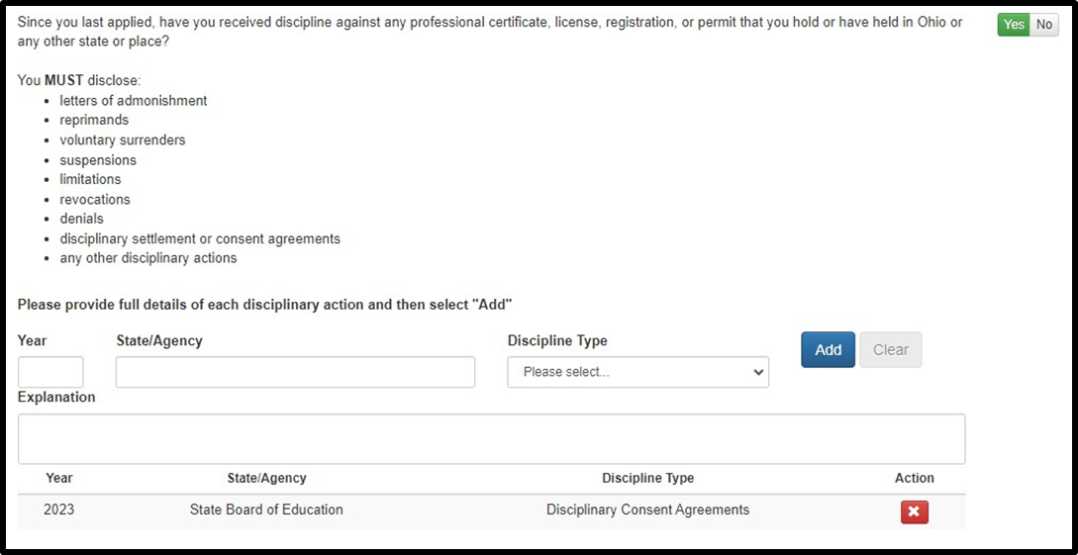

CRIMINAL HISTORY AND PRIOR LICENSURE DISCIPLINE ERRORS
If you improperly fill out any of the required sections above, you will receive an error message when trying to submit your application. Below are some common errors and instructions for how to resolve them.
- Leaving the Explanation Box Blank. If you select one of the Other categories for offense or discipline type, you are required to complete the Explanation box. You will receive an error message when you click the blue Add button until you complete this step.
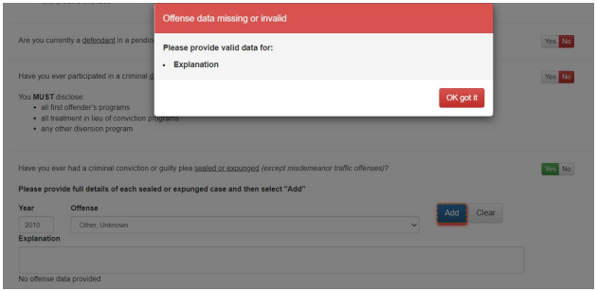

- Forgetting to Click the Add Button. If you do not click the blue Add button when you have finished filling out the appropriate conviction, pending criminal case diversion, sealed/expunged case, or license discipline, you will see the Offense Was Not Added error message. You must click the blue Add button to add your entered offense to the list.
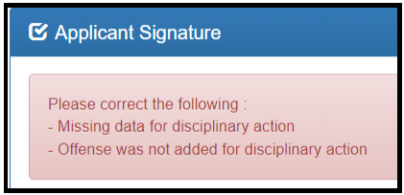

- Conflicting Information in Applications. If on a previously submitted application to the State Board of Education you answered Yes to any of these questions but answer No on your current application, you will receive an error message. You should either answer Yes and add the correct information to the appropriate question, or if the information you entered on the previous application was incorrect, you may click to bypass this error and submit your current application.

APPENDIX B

PROCEDURES FOR INTERNATIONAL CREDENTIALS

Candidates who completed college or university coursework or teacher preparation programs through an institution outside the United States are required to obtain a course-by-course analysis from an Ohio State Board of Education approved credential evaluation service. The State Board of Education will only accept credential evaluations from the institutions listed below. The addresses listed below are for mailing purposes only. Applicants must contact the credential evaluation service provider for document drop off information.

American Education Research Corporation, Inc. (AERC)
382 East Rowland Street
Covina, CA 91723-3154
626-339-4404
Email: aerc@verizon.net

Academic & Credential Records Evaluation & Verification Services (ACREVS)
8216 Princeton Glendale Road, #230
West Chester, OH 45069-1675
OR
1776 Clear Lake Avenue
Milpitas, CA 95035-7014
866-583-4834
www.acrevs.com
Email: info@acrevs.com

Educational Credential Evaluators, Inc.
101 W. Pleasant Street, Suite 200
Milwaukee, WI 53212-3963
414-289-3400
www.ece.org
Email: institutionsupport@ece.org

Educational Perspectives
P.O. Box A3462
Chicago, IL 60690-3462
312-421-9300
www.edperspective.org
Email: info@edperspective.org

Educational Records Evaluation Services (ERES)
2480 Hilbron Road, Suite 106
Fairfield, CA 94534
707-759-2866
www.eres.com
Email: edu@eres.com

Foundation for International Services, Inc. (FIS)
505 Fifth Avenue South, Suite 101
Edmonds, WA 98020
425-248-2255
www.fis-web.com
Email: info@fis-web.com

Globe Language Services
305 Broadway, Suite 401
New York, NY 10007-3626
212-227-1994
www.globelanguage.com
Email: info@globelanguage.com

Institute of Foreign Credential Services (IFCS)
6 Cedar Street
Dobbs Ferry, NY 10522
914-693-2840
www.ifcsevals.com
Email: info@ifcevals.com

International Education Research Foundation, Inc.
10736 Jefferson Blvd., #532
Culver City, CA 90230
310-258-9451
www.ierf.org
Email: info@ierf.org

Josef Silny and Associates
7101 SW 102 Avenue
Miami, FL 33173
305-273-1616
www.jsilny.com
Email:info@jsilny.org

Scholaro Inc.
29 E Madison Street, Suite 1005
Chicago, IL 60602
312-373-0952
www.scholaro.com
Email: support@scholaro.com

The Evaluation Company
450 7th Avenue, Suite 804
New York, NY 10123
646-475-2570
www.spantran.com/OhioDoE
Email: docs@evalcompany.com

World Education Services (WES)
P.O. Box 5087
Bowling Green Station
New York, NY 10274-5087
800-361-3106
www.wes.org
Email: docs@evalcompany.com

