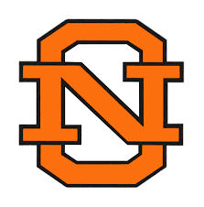
North Olmsted High School
27301 Butternut Ridge Road
North Olmsted, OH 44070

NORTH OLMSTED “SOUPER BOWL” FLAG FOOTBALL TOURNAMENT
NOVEMBER 23, 2025
NORTH OLMSTED HIGH SCHOOL STADIUM

DONATION FORM:
Company Name as you would like it to appear:

________________________________________________
Phone: ________________________________________________
Address: ________________________________________________
Email: ________________________________________________

Donation: $25.00 or other: _______________________

Payments can be made by CASH, CHECK or ONLINE
Check can be made out to: NO Athletic Boosters (with Flag Football in memo)
27301 Butternut Ridge Road
North Olmsted, OH 44070
Online: https://checkout.square.site/merchant/BQVWX3Y916C70/checkout/QI6MPWS6OSCSJ5Q5FFJT5GPU?src=sheet


Due to the quickly approaching date of our event, checks can be picked up by a NO Athletic Booster volunteer as well.

Thank You for your support!

