`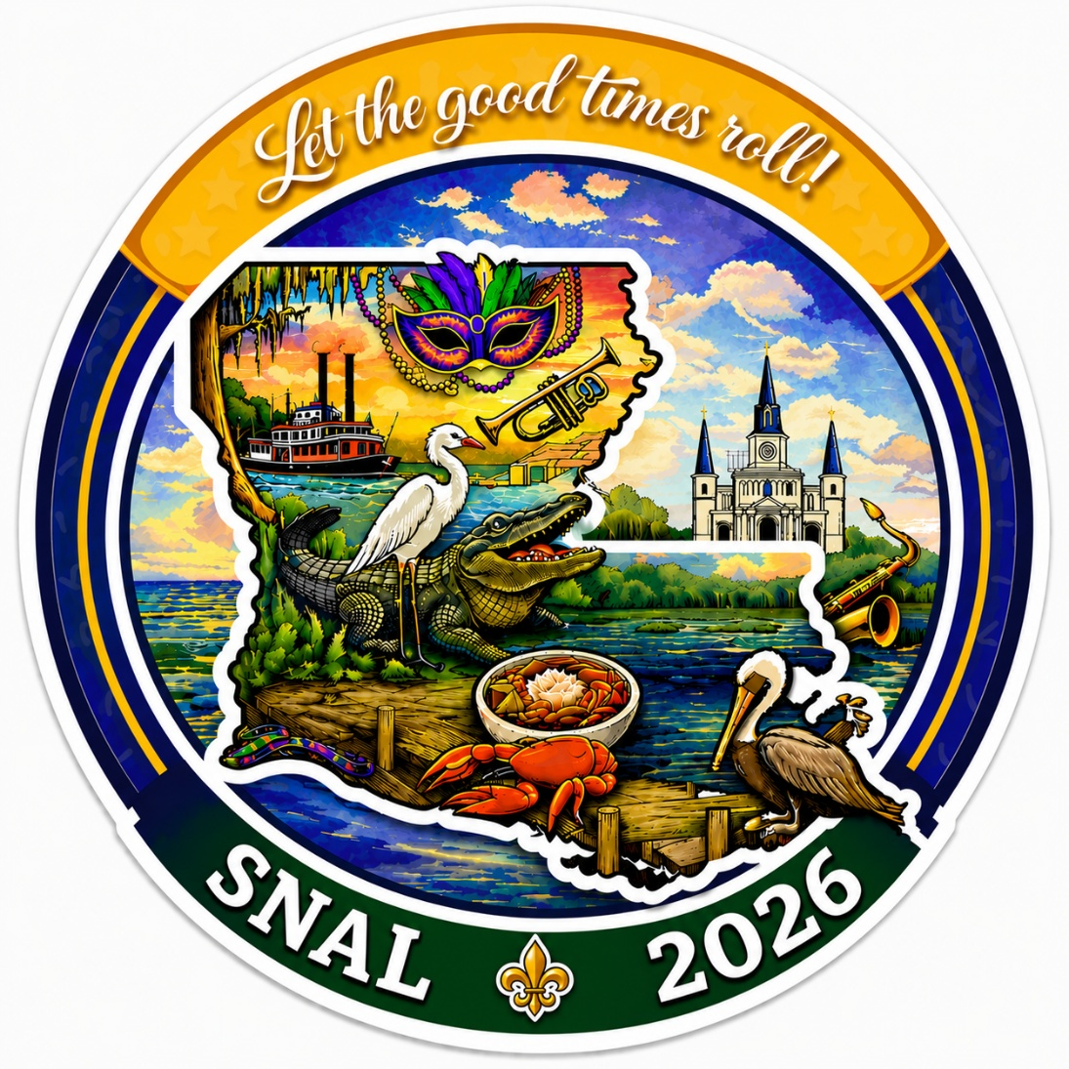

SNAL 2026 ANNUAL CONFERENCE
October 2 – 4, 2026
Sheraton New Orleans Hotel
New Orleans, LA

CONFERENCE PARTICIPANT REGISTRATION PACKET

The vision of the School Nutrition Association of Louisiana is to ensure that every student has access to nutritious meals at school, ensuring their optimal health and well-being. SNAL 2025 is designed for us to not only meet the goals set forth to achieve the vision, but to surpass them by solidifying our association as a purposeful voice for transformation and connection in shaping child nutrition program policy and operations. Our SNAL 2026 Conference Planning Committee is extending a special invitation for all members of the School Nutrition Association of Louisiana in LETTING THE GOOD TIMES ROLL because School Nutrition is evolving and finding joy necessary to be successful. Supervisors, Directors, Purchasing Agents, Managers and Technicians from across our great state will meet in New Orleans, October 2 – 4, 2026, at the Sheraton New Orleans Hotel. Our committee has been diligently planning education sessions, hands-on training and social events to make this an exciting and memorable 71th Annual Conference.

SNAL would like to thank all our participants for their continued support that enables us to fulfill the mission and vision of our organization. With the help of our committed exhibitors, we can offer training programs and services which will provide you with new ideas and enable you to create safe, healthy and nutritious meals for the children of Louisiana. If you have not attended a state conference before, we would like to extend an invitation to join us in New Orleans. An audience of dedicated child nutrition professionals along with manufacturer representatives will attend. Join us as we network, learn about new products and services, and share ideas to enhance your program therefore Letting the Good Times Roll in School Nutrition this 2026-2027 school year!

Conference Daily Summary
Registration Check-In will be set up at the Sheraton on October 2nd for everyone’s convenience. Registration will be set up on the 5th Floor outside the Grand Ballroom at the Sheraton New Orleans Hotel. See overview on next page for times.

Friday is comprised of pre-conference activities: SNAL Board meetings, House of Delegates, State Update, and Vendor Round Tables. NEW for this year, we will kick off the conference with our Night of Entertainment in the beautiful Armstrong Ballroom on the 8th Floor! Let the Good Times Roll! Join us as we dance the night away with “Queen Diva” Tracy Anne Jolie and The Beast of Bourbon, a local band who performs greatest hits from the 70’s through today and is guaranteed to keep the crowd moving!

Saturday is the FIRST DAY of the Conference! Chapter Presidents will meet prior to the First General Session to share ideas, learn about the SNAL plan of action for this year, and line up for the Parade of Presidents. The FIRST General Session will begin at 8:00 a.m. with the PARADE OF PRESIDENTS, the presentation of some of our SNAL Awards, and our exciting keynote speaker, Jeff Joiner! The Breakout Sessions start immediately at 10:10 a.m. Beginning at 11:20 a.m., there will be an exclusive hour dedicated to our Commodity Processors where Directors, Supervisors and other decision makers can focus specifically on commodities. The Exhibits will be open to EVERYONE at 12:30 p.m. until 4:30 p.m. Next up, join us in the Armstrong Ballroom at 5:15 p.m. – 6:45 p.m. as we sip our favorite beverages and paint “The Four Seasons of Louisiana”! Then plan to stay and play with us as Mardi Gras Madness Bingo beginning at 7:00 p.m. Feel free to wear your Mardi Gras accessories and win great prizes.

Sunday We will begin our day with a wellness stroll to the historic Jackson Square. Breakout Sessions start at 8:00 a.m. for everyone. Our 2nd General Session will begin at 10:30 a.m. followed by brunch. The last of awards will be distributed during this session along with the installation of our new SNAL board, the sharing of next year’s SNAL goals, and let us NOT FORGET – the drawing of the SNAL RAFFLE!

School Nutrition Association of Louisiana
71th Annual Conference Overview
October 2 – 4, 2026
Sheraton New Orleans Hotel

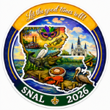

Friday, October 2nd
8:00 a.m. - 5:00 p.m. | Registration & Emporium | Grand Ballroom Foyer 5th Floor
8:00 a.m. - 4:00 p.m. | Vendor Move In/Setup | Napoleon - 3rd Floor
8:00 a.m. - 9:30 a.m. | Executive Board Meeting | Rhythms 1 & 2
9:45 a.m. - 11:30 a.m. | House of Delegates | Rhythms 1 & 2
12:00 p.m. - 2:00 p.m. | Directors Luncheon and State Update | Waterbury - 2nd Floor
2:30 p.m. - 4:30 p.m. | Vendor Round Table | Armstrong Ballroom 8th Floor
5:30 p.m. - 7:00 p.m. | Vendor Appreciation Reception | Waterbury - 2nd Floor
7:30 p.m. - 10:30 p.m. | Night of Entertainment | Armstrong Ballroom 8th Floor
Saturday, October 3rd
7:00 a.m. - 7:45 a.m. | Chapter President's Breakfast | Endymion/Mid-City
7:00 a.m. - 12:00 p.m. | Registration | Grand Ballroom Foyer 5th Floor
7:30 a.m. - 8:00 a.m. | Second Line | Grand Ballroom 5th Floor
8:00 a.m. - 10:00 a.m. | First General Session | Grand Ballroom 5th Floor
10:10 a.m. - 11:10 a.m. | Breakout Sessions (3) | Grand Ballroom 5th Floor
11:20 a.m. - 12:20 p.m. | Breakout Sessions (3) | Grand Ballroom 5th Floor
11:20 a.m. - 12:20 p.m. | Commodity Show - Directors and Decision Makers Only | Napoleon - 3rd Floor
12:20 pm. - 12:30 p.m. | Ribbon Cutting | Napoleon - 3rd Floor
12:30 p.m. - 4:30 p.m. | Food Show | Napoleon - 3rd Floor
5:15 p.m. - 6:45 p.m. | Louisiana 4 seasons painting | Armstrong Ballroom
7:00 p.m. - 8:30 p.m. | Mardi Gras Madness Bingo - wear your Mardi gras accessories | Armstrong Ballroom
Sunday, October 4th
6:00 a.m. - 7:00 a.m. | Morning Stroll to Historic Jackson Square | Meet in Lobby
7:00 a.m. - 7:45 a.m. | Table Decorating | Grand Ballroom 5th Floor
8:00 a.m. - 9:00 a.m. | Breakout Sessions (3) | Grand Ballroom 5th Floor
9:10 a.m. - 10:10 a.m. | Breakout Sessions (3) | Grand Ballroom 5th Floor
10:00 a.m. - 10:30 a.m. | Centerpiece Judging | Grand Ballroom 5th Floor
10:30 a.m. - 12:30 p.m. | Second General Session | Grand Ballroom 5th Floor
HOTEL INFORMATION

Rooms in the Sheraton New Orleans Hotel have been blocked for members and exhibitors. Reservations for the event are to be made by each individual. A credit card will be needed to reserve the room. King rooms and Two Double Bed room reservations are $229.00 per night plus sales tax (15%), New Orleans & Company Tourism Support Assessment (1.75% per night), and occupancy tax ($3.00 per room). There will be a $20.00 fee added to the nightly rate for each additional adult occupying the room (beyond2). Please go to this link to make reservations: https://book.passkey.com/e/51207438

************************************************
ABSOLUTELY NO PERSONAL CHECKS WILL BE ACCEPTED. INDIVIDUALS WILL BE RESPONSIBLE FOR SECURING THEIR RESERVATION BY CREDIT CARD. AN EARLY DEPARTURE FEE OF $229.00 WILL BE CHARGED IF YOU CHECK OUT EARLY WITHOUT NOTIFIYING THE HOTEL AT CHECK-IN OF THE CHANGE IN DEPARTURE. Check in time will be 4:00 P.M. and check out will be 11:00 A.M., unless late checkout arrangements are made with the hotel. Reservations must be made by September 10, 2026 (Cut-Off Date) to secure the group rate. Early check-in can be requested but is not guaranteed.

PARKING FEE
Hotel only has Valet parking services which are $48.00 per car/day. There are also several parking lots near the hotel and reservations may be made online https://neworleansparking.com/ . The Sheraton recommended Villere Lot located at 1539 Canal St.
If there are any issues with hotel reservations, contact Sandy Logrande, Conference Chair at 504-596-3443, or 504-322-0732.

SNAL 2026 REGISTRATION INFORMATION

ONLINE REGISTRATION 🖰: Please go to the SNAL website where all information must be entered online. www.snalouisiana.org

If anyone needs assistance to register online or has trouble, please contact:
Ellen Gauthreaux, Archdiocese of New Orleans, at egauthreaux@schoolcafe.org or call (504) 596-3450
Caroline Flax, Ouachita Parish, at carolinekelley@opsb.net or call (318) 398-1990, Ext: 315.

REGISTRATION FEES:
If you would like to attend the conference, the following fees apply:
Member Registration | Before Sept 19th | After Sept 19th
Full Conference
Technician/Mgr/Support Staff | $125.00 | $150.00
Supervisors/Directors/State Staff | $200.00 | $250.00
Retirees | $110.00 | $125.00
One Day | $110.00 | $125.00
Non-Member Registration | Before Sept 19th | After Sept 19th
Full Conference
Technician/Mgr/Support Staff | $175.00 | $200.00
Supervisors/Directors/Administrators | $335.00 | $350.00
One Day | $125.00 | $140.00
Full Conference Registration includes admittance into breakout and general
sessions, Exhibits & Food Expo, Night of Entertainment and Closing Banquet.
One-Day Registration only includes admittance to breakout and general sessions
occurring during the selected day.

PAYMENT INFORMATION:
Credit Card or Check
EXTRA TICKET PRICING
Sit and Paint: $30
Mardi Madness Bingo: $10

Vendor Appreciation: $50
Night of Entertainment: $40
Installation Banquet: $50
T-Shirt: All Sizes $25
Chapter President Breakfast: $10.00

HOSTESSES ARE NEEDED
With the number of Breakout Sessions and Activities scheduled, the SNAL Conference Committee will definitely need assistance handing out Door Prize Tickets and assisting everyone sign up for CE Hours in each room. Please see the form provided in this packet to sign up for FUN and a great opportunity to NETWORK!


Friday, October 2, 2026

New Board Orientation
All newly appointed Executive Board members are required to attend Executive Board Orientation on Friday, October 2nd 8:00 am - 9:30 am in the Rhythms Room 1 & 2 on the 2nd floor. Breakfast will be provided. Please make every effort to attend orientation. You will learn parliamentary procedure, financial management, as well as understand your role in our 2026-2027 Plan of Action to advance SNAL. Outgoing board members are encouraged to participate to aid in transitioning new board members.
Executive Board Meeting
The SNAL Executive Board Meeting will take place on Friday, October 2nd 8:00 am - 9:30 am in the Rhythms Room 1 & 2 on the 2nd floor. Everyone on the board is to attend to finalize all aspects of the conference to ensure that SNAL 2026 is one of the best experiences for our members!!!
House of Delegates
The official business of SNAL is conducted at the House of Delegates (HOD). A meeting is scheduled for Friday, October 2nd 9:45 am - 11:30 am in the Rhythms Room 1 & 2 on the 2nd floor. The check-in will be from 9:30 am – 9:45 am. An agenda and proposed bylaw changes will be sent by email to every qualifying delegate from active chapters.

Directors Luncheon/ State Update
Program Supervisors and Directors are invited to a luncheon in the Waterbury Ballroom on the 2nd Floor. Come join others in attendance who will share the challenges of last year’s Administrative Reviews and hear how they solved those problems. This session will transition into the STATE UPDATE.

Vendor Round Tables
The Vendor Round Tables allow supervisors and directors to visit with a variety of vendors for 5 minutes each to see what is up and coming at their booth the following day. This is an opportunity for vendors to get a little more quality time with our Directors, Supervisors, and Decision Makers. We like to call this “speed dating” our vendors. Last year’s Round Tables were a hit! You do not want to miss out!

Night of Entertainment
We will kick off the conference with our Night of Entertainment featuring “Queen Diva” Tracy Anne Jolie and The Beast of Bourbon, a local New Orleans band who performs greatest hits from the 70’s through today and is guaranteed to make you want to dance the night away!

SATURDAY, October 3, 2026

Key Note Speaker
For our opening general session, we will have the opportunity to listen and learn from Jeff Joiner. Jeff has spoken at SNA State and National Conferences. Jeff will also host two breakout sessions.

Chapter Presidents Breakfast
Chapter presidents are vital to advancing the Plan of Action of SNA and SNAL. We invite current and incoming Presidents to attend this working breakfast on Saturday, Oct 3rd , 7:00 am – 7:45 am. We will assess your role and expectations as President. We will review the SNAL Strategic Plan for SY 26-27 to help prepare your Chapter to achieve the President's Award of Excellence (Gold). This workshop is designed to share ideas for success and enhance your professional leadership growth. Breakfast is $10 and will be added to the registration total. If you have any questions or concerns, please contact:

Ellen Gauthreaux, SNAL President Elect
egauthreaux@schoolcafe.org
504-596-3450

Vendor Exhibits and Food Expo
Come and see what new and innovative equipment, food, and services our industry has to offer. Vendor exhibits will open on Saturday, October 3rd. The Ribbon Cutting is at 12:20 p.m. The door will open to all participants at 12:30 pm – 4:30 pm.

Conference T-Shirts 🖰
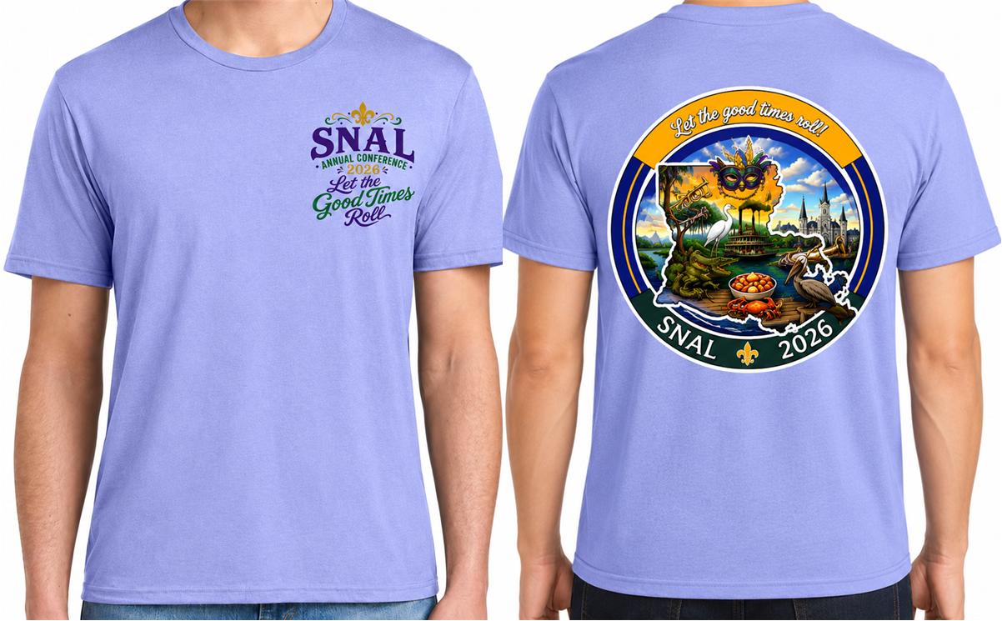

Price for this year’s conference T-Shirts, no matter what size, is $25 (S, M, L, XL, 2XL, 3XL and 4XL). Please indicate size and quantity when ordering online. Please keep in mind that we will have limited sizes and quantities available for sale at conference. The DEADLINE TO ORDER SHIRTS is Friday, September 11th. Register early, the option to purchase will be removed from the registration page after September 19th.

SNAL Raffle
You can win BIG with our annual fundraiser raffle. The grand prize is $1,000.00. We will also give away 2 - $500 prizes, 2 - $250 prizes and 4 - $100 prizes. If you cannot purchase your raffle ticket prior to the conference, you will be able to do so at a booth set up in the Conference Center. The drawing will take place at the Closing General Session's banquet, on Sunday morning.

Special Needs
If you require special assistance, please let us know. On the registration form, indicate the accommodation needed.

Dietary Restrictions
Vegetarian options will be made available at our Chapter President Breakfast, Director’s Luncheon, and Closing General Session Banquet. Please indicate if you require a vegetarian meal choice or a life-threatening food allergy.

ATTENTION: Looking for SNAL Members
To Serve as a Host/Hostess at SNAL Conference!

We want you to help serve as hostesses at the 71st annual conference of SNAL in New Orleans, Louisiana on October 2nd – 4th !
Who can apply? Anyone who is planning to attend the conference likes to meet new people and wants to see what putting on a conference of this magnitude is all about!
What would you be doing? Just to name a few of the activities where your help is needed – you might be providing directions to functions, giving out door prize tickets, handing out door prizes, assisting the running of the SNAL booth in the exhibit area, or assisting with registration or a speaker at different functions or events. The attire is a white shirt with black pants.
How long would I have to work? No more than an hour or as long, and as often, as you would like!

How do I sign up? Contact: Donna David
Archdiocese of New Orleans
ddavid@schoolcafe.org
504-596-3452
What do we need to know? Please email the following information:
1. Name of Parish
2. # of Host/Hostesses available during conference
3. Name, cell phone #, and day and time for each person available to participate

Thank you so much! Please send your Host/Hostess information in as soon as possible!

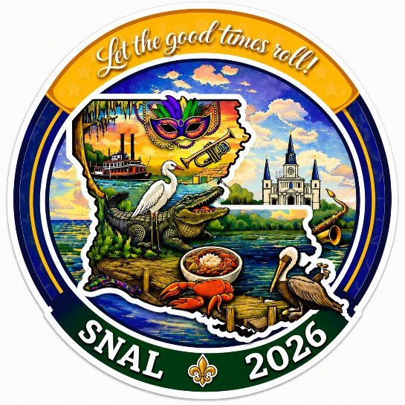

DOOR PRIZE REQUEST FORM
The support you give to the School Nutrition Association of Louisiana (SNAL) serves as its foundation. Therefore, we are asking all chapters to contribute gift cards valued at a total of $25.00 or more. Please do not exceed $25.00 per gift card. You may choose to donate, for example, $15.00 on one gift card and $10.00 on another gift card to make up your $25.00 donation.
Door prizes will be awarded at each General Session and at each breakout session during the 2026 conference. Below you will find the form to submit with your gift card or donation. We will recognize all Chapters in our conference program booklet and at our general and breakout sessions, so please do not forget to put your Chapter name.
If your chapter plans to contribute to door prizes for the conference, please respond.
Claire Delerno
Address: 4600 River Rd., Marrero, LA 70072
Email: claire.delerno@jpschool.org
Phone Number:504-349-8605
DOOR PRIZE SUBMISSION FORM
Chapter Name:
Contact: | Phone Number:
Email Address:
____ $25.00 Gift Cards _____ $15.00 Gift Cards _____ $10.00 Gift Cards
MAKE CHECKS PAYABLE TO: SNAL

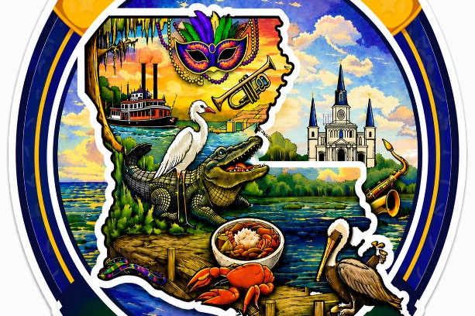

Silent Auction Donation
The SNAL Conference Committee is busy making plans for an outstanding conference. The silent auction is an important part of our many activities. SNAL Chapters are asked to contribute items for this worthy event! All Chapters will be recognized in the conference program for their contributions if they are received on or before Friday, September 11th.
Donation Suggestions: A basket filled with items that are unique to your parish or chapter, a donation from a business, cookware, tote bags, art, an item made by someone in your parish or chapter or any other gift you wish to give that would be easy for a recipient to transport. Whatever you choose to give will be greatly appreciated and will give us a variety of items to be offered at auction!
If a Chapter plans to donate one or more items, please contact:
Name: Sandy Logrande
Phone Number: 504-596-3443
Email: slogrande@schoolcafe.org

Please complete one sheet for each item donated and return it to me as soon as possible.
Chapter Name: _____________________________________________
Contact Person: _________________________
Phone Number (cell preferred):________________
Value of Item: $__________________________
Item(s) to be contributed: __________________________________________________
Deliver to conference on Friday 10/2___ or Sat 10/3___ at the registration check in desk.
Thanks for your help to make the
SNAL 2026 Conference a Success!!
2026 Parade of Presidents

PARISH: ____________________________________

WILL YOU BE ATTENDING THE STATE CONFERENCE IN NEW ORLEANS? YES,____ NO___
NAME: ____________________________________ TITLE: ____________________________
YEARS IN FOOD SERVICE: ______________ GOLD AWARD WINNER___________________
WORK ADDRESS: _______________________________ WORK EMAIL: ________________
WORK PHONE: __________________________ HOME ADDRESS______________________
HOME EMAIL: ______________________________ HOME PHONE: _____________________
CELL PHONE: ______________________________
PREFERRED METHOD OF CONTACT: HOME________ WORK________ CELL________

ACCOMPLISHMENTS/HIGHLIGHTS:__________________________________________________________________________________________________________________________________________________________________________________________________________________________________________________________________________________________________________________________________________________________________________________________________________________________________________

TOP FUNDRAISER: ____________________________________________________________
____________________________________________________________________________

HOBBIES: ________________________________________________________________________________________________________________________________________________________________________________________________________________________________________________________________________________________________________

WHAT WOULD BE YOUR CAREER CHOICE IF YOU WERE NOT IN SCHOOL FOOD SERVICE? AND WHY?__________________________________________________________
________________________________________________________________________________________________________________________________________________________

WHO IS YOUR MENTOR, IDOL OR THE PERSON THAT ENCOURAGED YOU THE MOST AND WHY? __________________________________________________________________
________________________________________________________________________________________________________________________________________________________
RETURN FORM TO: Ellen Gauthreaux, Email- egauthreaux@schoolcafe.org

TABLE DECORATING INFORMATION & GUIDELINES
This is a fun opportunity to express yourselves and be creative! It is also an opportunity to guarantee that your group will sit together during the installation ceremony banquet. But most of all it is a way for you to be recognized for going the extra step to be a Child Nutrition Motivator!

1. You must use the table(s) reserved for you. Your name and parish will be on your table(s).
2. You must use the conference theme: Let the Good Times Roll in Child Nutrition
3. You must use the color scheme of Purple, Green, and Gold.
4. Your space to decorate will be the center of a round banquet table, about 15-18” square.
5. DO NOT use any confetti or glitter spray as we will be charged an additional cleaning fee.
6. This year we will display the centerpieces on a table for everyone to enjoy and for judging before the banquet.
7. You will be informed about the location of the display table in an email before the conference.
8. The number of tables you can request to decorate is based on how many people will be in your group. The tables will be set up to seat 8. If you have 8 people you get one table. If you have 5 people, you get one table and have the pleasure of sharing the other 3 seats with fellow conference attendees. Please email Ellen Gauthreaux with the number of tables/table decorations you will need.
9. All groups participating in the contest will be verbally recognized during the banquet.
10.All entries must be homemade. No premade flower arrangements or store-bought centerpieces will be allowed.

Reminder: This contest is the only allowable method to reserve seating for the Closing General Session banquet.

You will find the entry form on the next page. If you would like to participate, please complete the form.

Annual Tabletop Contest
The Table Top Decorating Contest will be held before the Last General Session at SNAL 2026, Sunday, October 4, 2026. It is a great way to show your creativity and also a great way to ensure your group sits together. Tables will be distributed on a first come first serve basis so make your plans now!
Name of Responsible Party ____________________________
Cell Contact Number__________________________________
Contact Email _______________________________________
Name of Parish/Chapter ______________________________
Number of Tables Needed _____________________________
Number Seated at Each Table __________________________

Return Entry Form Via:
Email: egauthreaux@schoolcafe.org

DEADLINE: PLEASE RETURN THIS FORM BY September 11, 2026

