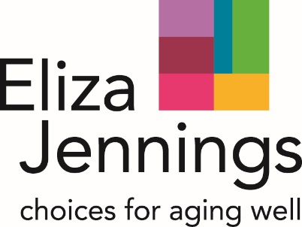

**Interested in a job in the healthcare field?   
Eliza Jennings Senior Care Network is looking for enthusiastic and dedicated individuals to become part of our team!   
We are currently hiring at all three locations:**

**Eliza Jennings Home**  
10603 Detroit Ave, Cleveland, Ohio 44102  
Contact: Heather Borrelli, (216) 226.0282, ext. 3218 or [hborrelli@elizajen.org](mailto:hborrelli@elizajen.org)

**The Renaissance Retirement Campus**  
26376 John Road, Olmsted Township, Ohio 44138   
Contact: Kara Kolodziej, (440) 235.7100, ext. 2311 or [kkolodziej@elizajen.org](mailto:kkolodziej@elizajen.org)

**Devon Oaks Assisted Living**  
2345 Crocker Road, Westlake, Ohio 44145  
Contact: Kimberly Hernandez, (216) 325.1253 or [khernandez@elizajen.org](mailto:khernandez@elizajen.org)

**To browse our current open positions**, go to: [www.indeedjobs.com/eliza-jennings](http://www.indeedjobs.com/eliza-jennings)

**We offer a range of growth paths in health care, including resident care, food service/dietary, environmental services and more!**

**Education and tuition support available!**