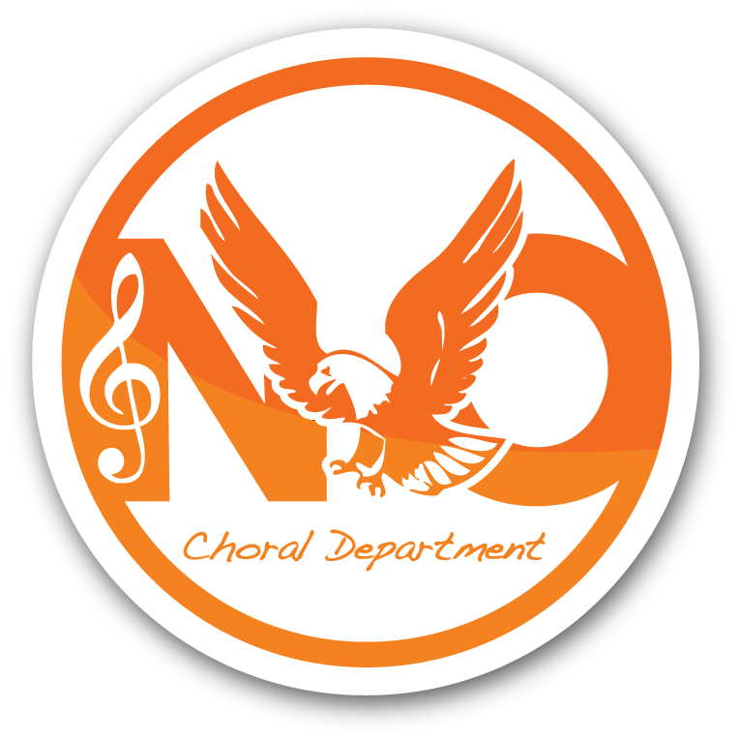
North Olmsted Choral Families:

This letter is intended as an invitation, as well as reminder of guidelines for our upcoming Holiday Choral Concert on Wednesday, December 17th @ 7pm. Your students have been working tirelessly to put on a concert featuring a lovely variety of traditional, classical, spiritual and contemporary selections, prior to their break. The concert will begin with the 6th/7th/8th choirs, and a short intermission after two large combined numbers and an appearance by a “special guest.”. The second half of the concert will feature our HS choirs and contemporary a cappella program. Middle school students are not required to stay beyond the intermission, but are encouraged to stay to see the opportunities that they will have in the coming years. ALL students will either be seated off to the side for the concert, or in the music rehearsal rooms, and the audience is encouraged to support appropriate concert etiquette – i.e. zero noise, no phones, etc. Below are the details for the concert, as well as a few other traditional tasks that we take on from year to year, during this holiday season.

- December 17th – Holiday Concert
  - 2:15-3:00 HEADLINES to PAC stage for Sound Check
  - 5:45 ALL HS choral students drop belongings in designated practice room
  - 6:00 ALL HS choral students arrive at PAC (Auditorium)
    - Rehearsal
    - Please have students eat and get dressed beforehand; concessions are at a minimum
  - 6:15 ALL MS choral students drop belongings in designated practice rooms
  - 6:30 ALL MS choral students arrive at PAC (Auditorium)
    - Rehearsal
  - 7pm Concert begins
    - ADMISSION - 2 canned goods per person OR $3 (scholarship fund); Families of 4 or more, 2 canned goods per person OR $5 for entire family (scholarship fund)
      - Non-perishables/toiletries will be donated to Local Pantries
      - $$$ will be held for the N.O. Choral Booster Scholarship
  - 7:45 Approx. – 1st Half Concluded; Grades 6-8 MAY LEAVE, if desired.
  - 9pm – Concert concluded (Remaining students required to assist)
    - Teardown (Concessions/Monitors/Microphones)
- Leading Up To The Concert
  - Food/Toiletry Drive! Baritones vs. Altos vs. Sopranos
    - Please consider donating to support local families in need
Reminder (Also sent in October)!!! Dress for the 6th/7th/8th & Concert Choir will be:

Ladies: White blouse
Long black skirt (knee-length or longer; no denim) or black
dress slacks
Skin-tone hosiery
Black, close-toe flats

Men: White dress shirt
Black dress pants (no denim)
Tie (simple patterns, no “crazy” ties please)
Black dress socks
Black dress shoes
Alex Phan
Director of Choral Activities, District Music Coordinator
North Olmsted City Schools
School: 588-5300 ext. 6107
alex.phan@nocseagles.org

