Looking for a Summer Job?

Do you have an interest in Golf/Sports?

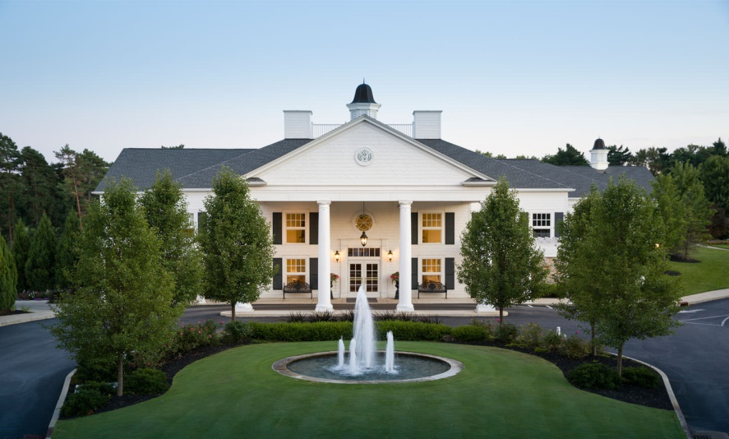

Come Join the Westwood Country Club Staff!

**Golf Positions Available**

- Outside Service / Outside Service Managers

- Golf Shop

- Caddie

Click to apply - [Application](https://docs.google.com/forms/d/e/1FAIpQLScTf96_XGdvHF-vCI0LaZS7eUc3Rp5QLi3nEMHysmuTbjbeug/viewform?usp=sf_link)

or

Contact - Adam Stinogle, Head Golf Professional

by email

astinogle@westwoodcountryclub.org